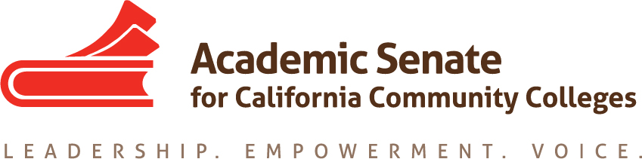

ASCCC ONLINE EDUCATION COMMITTEE

October 1, 2020

4:15PM – 7:30PM

Zoom Conferencing

https://laccd.zoom.us/j/99933291559

AGENDA

- Call to Order

- Adoption of the Agenda

- Approval of Minutes
  - From September 3, 2020

- Action Items
  - Consider updating ASCCC Online Education Committee charter OR consider if this committee needs to maintain in existence or if the ongoing efforts can be embedded in the other aspects of the ASCCC work
  - Participation of Online Education committee members in Fall 2020 Plenary breakout sessions (Volunteers)
  - Ongoing professional development:
      - technology/online instruction for lab classes
      - discipline specific online education

  - Address Assigned Resolutions
    - Resolution 09.03 S13 : Conditions of Enrollment for Online Instruction (High Priority) – Rostrum Article; Consider if any Title 5 Regulation changes are needed.
    - Resolution 09.03 F18 : Local Adoption of the California Virtual Campus Online Education Initiative Course Design Rubric – Rostrum Article
    - Resolution 09.04 S19 : Ensure the Accessibility of Educational Materials – Rostrum Article or White Paper – Maria Guzman has volunteered to serve as a research resource.
  - Assigned Tasks
    - Rostrum Articles
      - Due by January 4, 2020
      - Due by March 8, 2020
    - Resolutions from the Committee
      - Final Resolutions due for Area Meetings by October 1, 2020 – do we want to draft and submit any resolutions for Fall Plenary? Maybe a resolution for IVc?

  - Meetings dates/times
    - Once per month (day/time) – Every 1st Thursday 4:15pm-5:30pm
    - Face-to-face – Fall 2020: Extended October 1, 2020 meeting to 7:30pm and added another meeting for October 15, 2020 from 4:15pm – 7:30pm

- Future Action Items
  - ASCCC Strategic Plan – Review the strategic plan for areas this committee should be implementing within our work)
  - Committee Priorities- TBD (Recommended by the 2019-2020 Online Education Committee)
    - Resolution 07.01 S14 : Explore Participation in SARA for DE Offerings (High)
    - Stay aware of the status of the DE Guidelines (DEETAC/CCCCO)
    - Consider requesting a representative from the SSCCC (was requested in 2019-2020, but did not receive an appointment)
    - Consider including faculty representatives on committee: accessibility specialist, DEETAC, Calbright AND invite CVC-OEI representatives to meetings, when appropriate
    - Online Education— Outstanding Faculty/Course Recognition: The Executive Committee discussed recognizing faculty and online courses in partnership with CVC-OEI, including the nomination process, selection process, and various forms of recognition such as opportunities to host webinars, faculty spotlights, and showcases. The Online Education and Standards and Practices Committees will consider developing a means to recognize outstanding online educati on faculty and courses.
    - Address fully online pathways with CVC-OEI (particularly in light of COVD 19)
    - Ongoing professional development:
      - DE Guidelines (when approved/ready for dissemination)
      - CVC-OEI POCR changes/updates

- Announcements
  - ASCCC EVENTS:
    - Academic Academy Virtual Conference – October 8-10, 2020 “Redefining Distance Education”
    - Fall Plenary Session Virtual Conference – November 5-7, 2020 “Addressing Anti-Blackness and IDEAs (Inclusion, Diversity, Equity and Anti-Racism) in Academic and Professional Matters”
  - Other ASCCC Committee Reports- TBD

  - Resources:
    - Ensuring an Effective Online Program: A Faculty Perspective (spring 2018)
    - Distance Education Guidelines
- Adjournment
Status of Previous Action Items

- In Progress

- Completed

