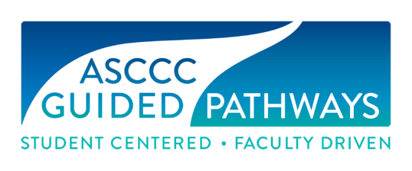
Guided Pathways Task Force Meeting
Minutes
Wednesday, February 10, 2021
12:00 p.m. – 2:30 p.m.
Via Zoom
In attendance: Virginia “Ginni” May, Cheryl Aschenbach, Michelle Bean, Juan Buriel, Stephanie Curry, Sarah Harris, Jeffrey Hernandez, Meridith Selden, Erik Shearer, Miguel Rother, Selena Silva
Action | Item
Discussion |  | Welcome and Check-in (20 min)  Members checked in with each other
Information/Report |  | Announcements/Updates (60 min)  - ASCCC Executive Committee Meeting  - Chancellor’s Office Guided Pathways Advisory Committee  GPAC just met, so attendees were still processing information that was delivered during the meeting. From questions asked, it does not seem that GP will be supported at the system level as the funding runs out. If funding is sought, it will be for very specific reasons and outcomes. College funding reports will be due July 2022. Also, it has become clear that the SOAA is not a valuable source of data. GPAC may be phased out and will transition to a focus on the Ensure Learning pillar. A new intended graphic was introduced for the Ensure Learning focus (Ensure Learning with Equity Strategy, w/emphasis on Learning Environment, Learning Teams, Learning Materials & Curriculum, and Learning Outcomes Data. Guided Pathways now has a Launchboard space for data.  - Resolutions  - F20 17.01 Stephanie is leading this mini-paper effort  - F20 18.01 For 2nd resolved, GPTF and Curriculum Committee chairs initiated a proposal. For 1st resolved, reports on some of the work in the Optimizing Student Success fall 2020 paper via Rostrum or webinar took place. More support is needed.  - GPTF Teams  - Webinars – Sarah is helping to lead this effort. She’s been working with GPTF input to put a schedule together. She reviewed ideas as well as input received.  - Technical Visits – A letter went to all GP Liaisons. At this point, we haven’t had any new requests for GP-related technical visits.  - Resources – Meredith has added everyone into the GP Resources folder.
Break - 10 min
Discussion/  Action |  | 2021 Spring Plenary Session (30 min)  - Resolutions – the committee discussed potential resolutions to propose for spring plenary and agreed to begin developing a couple of the ideas via Google docs. Committee resolutions are due February 16.  - Area Meetings – Area meetings are March 26 & 27  - Breakouts – There is currently one GP-related breakout proposed for Spring Plenary. Sarah, Jeffrey and Meredith will be attending Plenary and are willing to help if needed.  - Elections – ASCCC elections will be conducted online again. Ginni encouraged people to run if they are interested.
Information/Report |  | Mini Papers/Mini Canvas Courses Group Updates (30 min)  Members gave updates regarding process on the mini papers/mini course resource development
List of Agenda Enclosures
Enclosure 1: 17.01 Fall 2020 Integration of Guided Pathways Work and Institutional Processes and Structures
Enclosure 2: 18.01 Fall 2020 Paper and Resources for Evaluating Placement in English, English as a Second Language, and Mathematics Pathways

