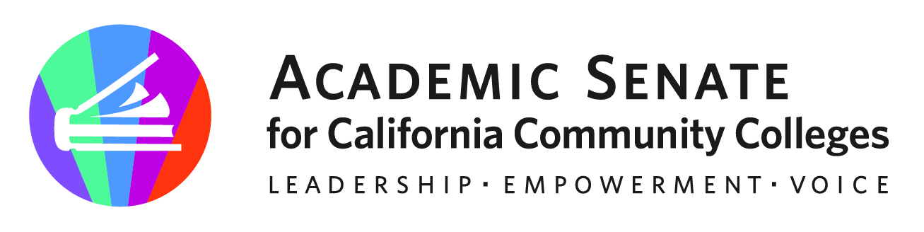

ASCCC Executive Committee Agenda Item

Month: Dec Year: 2022
SUBJECT: Legislative & Advocacy Day
DESIRED OUTCOME: The Executive Committee will consider for approval dates for ASCCC Spring 2023 Legislative and Advocacy Day
CATEGORY: Action
REQUESTED BY: Aschenbach
STAFF REVIEW:

Item No:
Attachment: No
Urgent: Yes
Time Requested: 5 minutes
TYPE OF BOARD CONSIDERATION
Consent/Routine:
First Reading:
Action: X
Information:
Please note: Staff will complete the grey areas. Staff will review your item and provide additional resources to inform the Executive Committee discussion.

BACKGROUND
In February, ASCCC holds its Annual Legislative and Advocacy Day. Teams of Executive Committee members and Legislative and Advocacy Committee members conduct visits with legislators and legislative staffers to inform about ASCCC, its work on behalf of community college faculty and students, and its priorities.
On the afternoon prior to the Legislative and Advocacy Day, an advocacy training takes place for all participating members.
Proposed date: Tuesday, February 21 (afternoon training) and Wednesday, February 22 (all day), 2023
Once dates are set, the ASCCC office team will begin reaching out to legislative offices. Visits may be in-person or via Zoom depending on preferences of the legislative offices.

