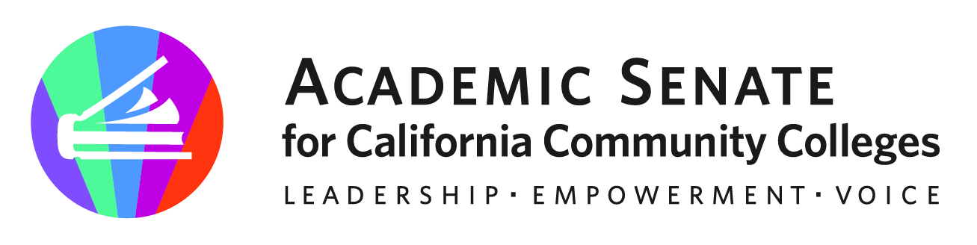

ASCCC AREA A MEETING

March 24, 2023

10am-3pm

AGENDA

- Call to Order, Adoption of the Agenda

- Welcome! & Attendance

Sign in here https://padlet.com/stephaniecurry/area-a-sign-in-2dkvbhjm6htx3z5i

- Reports
    - ASCCC Presidents Report – Cheryl Achenbach, ASCCC Vice President
    - ASCCC Foundation Report- ASCCC Foundation

- Resolutions
    - Review of Resolutions Process
    - Review of Packet
    - Additional Resolutions from the Area

- Disciplines List
    - Timelines
From Disciplines List website: “In February, the process for formally reviewing the Disciplines List, which establishes the minimum qualifications for the faculty of California community colleges, was initiated. This letter serves as a notification that the ASCCC is currently accepting proposals to revise the Disciplines List for the 2022-2023 cycle. As a reminder, the review process is now an annual process. The deadline for submission of proposals is September 30, 2022. Proposals received after the deadline may be held for the 2023-2024 cycle.”
    - Proposals- Spring 2023 Ethnic Studies
    - Hearings : Friday, April 21, 8:00 AM -9:00 AM at Spring Plenary

- Reports and Updates from Local Colleges

- Announcements/Events
  - ASCCC Webinars on ASCCC Events Calendar
  - 2023 Spring Plenary (April 20-22, 2022)
  - 2023 Faculty Leadership Institute (June 15-17, 2023)
  - 2023 Curriculum Institute (July 12-15, 2023)

- Adjournment

