Changes to Assessment, Placement, and Instruction in Mathematics:
Survey Results Reporting on Implementing AB705 (Irwin 2017)

Introduction
The passage of AB705 (Irwin, 2017) fundamentally changed how colleges assess and place students into courses in mathematics, English, and English as a Second Language (ESL). Instead of using placement tests as a component of multiple measures assessment, colleges were compelled to use high school grade point average (GPA) as the multiple measures assessment. By fall 2023, based on data validation protocols determined by the California Community Colleges Chancellor’s Office (CCCCO), all colleges were required to place all students into transfer level courses with or without required support (with limited exceptions).

While some colleges found this transformation increased completion for first-time students enrolling in English or mathematics for the first time, other colleges struggled to implement the requirements of the law without having student success rates decrease. In the fall of 2020, Resolution F20 18.01 (https://asccc.org/resolutions/paper-and-resources-evaluating-placement-english-english-second-language-and-mathematics) was adopted and it called for:

Resolved, That the Academic Senate for California Community Colleges, in collaboration with system partners, write a paper on optimizing student success by evaluating placement in English, English as a Second Language, and mathematics pathways for consideration at the Spring 2022 Plenary Session.

Resolution F20 18.01 cites an ASCCC Guided Pathways Task Force (GPTF) paper titled, “Optimizing Student Success: A Report on Placement in English and Mathematics Pathways.(https://asccc.org/papers/optimizing-student-success-academic-senate-white-paper)” The paper outlines recommendations for data elements that faculty should be involved in collaborative methods of analysis and in-depth study. The paper recommends questions that colleges should incorporate into local research questions to investigate the changes to placement in light of AB705. This present paper builds on some of the earlier recommendations made by the GPTF paper.

To develop a paper that would highlight successful implementation strategies and point out areas where colleges were still struggling, the Academic Senate for California Community Colleges (ASCCC) created the Data and Research Task Force (DRTF). The DRTF’s charge was to:

“...to respond to Resolution F20 18.01 and to assist local academic senates in using data effectively to improve teaching and learning. The DRTF will work to establish data-driven processes to evaluate and advance diversity, equity, and inclusion in areas of academic and professional matters and leverage the Guided Pathways framework which includes data examination and exploration to improve educational programs and services to students.” (https://asccc.org/directory/data-and-research-task-force)

To respond to Resolution F20 18.01, the DRTF developed three surveys (one each for mathematics, English, and English as a Second Language) that were distributed to colleges in early spring of 2022. Subsequently, the ASCCC Executive Committee approved the formation of the Data and Research Committee (DRC) whose mission is:

“…to assist local academic senates in using data effectively to evaluate educational programs and services to improve teaching, learning, and student success. The DRC will work with ASCCC Standing Committees, task forces, and other workgroups to establish and improve data-driven processes to advance inclusion, diversity, equity, anti-racism, and accessibility (IDEAA) in areas of academic and professional matters. The DRC may also conduct data analyses to assess the effectiveness of statewide issues and initiatives in areas of academic and professional matters.”

Among the responsibilities and goals of the inaugural DRC in the 2022-23 academic year was to continue the work of the DRTF and analyze and report the results of the DRTF surveys administered. Response rates varied, but the largest number of responses were received from faculty in the mathematics discipline. Because the surveys did not provide all of the information necessary for a position paper, the ASCCC Executive Committee decided to develop a series of resource (white) papers, beginning with equitable placement and enrollment into mathematics and related disciplines. The goals of this paper are to highlight the results from the surveys, indicate any promising practices that were shared, and to highlight areas where colleges are still struggling with implementation that meet the needs of the students they serve.

History
Placing students in courses in English and mathematics has been a challenge for colleges. For many years, assessment tests were the primary tool used to place students into their first mathematics course. Hoping to develop more consistent and equitable placement across the system, the 2012 Seymour-Campbell Student Success Act created the Common Assessment Initiative (CAI) which called on the California Community Colleges to develop a single set of assessment tests for all students that could be used as part of multiple measures assessment. The hope and goal were to improve the quality of assessment testing while providing students with test results that they could use at any community college. The goal of the assessment process was to place students into the course in which they were most likely to be successful. Students were often placed into pre-transfer-level courses that would help them build their skills and improve the likelihood that the student would complete a transfer-level course.

The adoption of AB705 (Irwin, 2017) shifted placement from using assessment tests as a component of multiple measures assessment to the use of high school performance data, specifically grade point average (GPA). The use of high school performance data had been part of multiple measures long before AB705. A group of colleges had been working with the Multiple Measures Assessment Project (MMAP) to develop decision trees that placed students into college courses using assessment test results in addition to high school GPA, high school courses completed, and their corresponding course grades. The decision trees used prior to AB705 were designed to maximize the likelihood that the student would successfully complete the course in which they were placed.

Whether using an assessment test or high school data to place students, the ultimate goal was to maximize success in the course where the student was placed. With the passage of AB705 a new metric called throughput was created. Throughput measures the likelihood that a first-time student will enter and complete a transfer-level course within one year from their first enrollment in the discipline. The shift from likely course completion to throughput is a far greater change than moving from assessment tests to placement based on high school GPA. With the single emphasis on throughput combined with greater numbers of students being placed into transfer-level courses, the aggregate numbers will almost certainly show higher numbers of students completing transfer-level courses within one year.

After the passage of AB705, Title 5 §55522 was amended to mandate college placement practices in English, ESL, and mathematics with a focus on throughput and data collection to show that placement of students in pre-transfer-level courses would have a higher throughput (within a one-year timeframe) than direct placement into a transfer-level course. Title 5 § 55522 (https://govt.westlaw.com/calregs/Document/I650A17834C6911EC93A8000D3A7C4BC3?viewType=FullText&originationContext=documenttoc&transitionType=CategoryPageItem&contextData=(sc.Default)) pertaining to English and Mathematics Placement and Assessment (Placement methods) contains reference to throughput in (c).1.B.ii. “A district placement method using localized research must be supported by data and research showing throughput rates at or above those achieved by direct placement into a transfer-level course (or college-level courses where appropriate). Such data and research must be validated within two years of adoption of the method. The Chancellor shall regularly publish throughput rates achieved by direct placement into transfer-level courses (or college-level courses where appropriate), based upon the best available research at the time of publication,” and section c.3.B (3), “Districts adopting a district placement method under subparagraph (c)(1)(B) or (c)(1)(C) shall, by July 1, 2019, provide an adoption plan on a form prescribed by the Chancellor, explaining the placement method and why the district believes it will be effective. Within two years of the adoption of a district placement method, the district shall report to the Chancellor on the method’s efficacy. The Chancellor may order the district to relinquish the district placement method and adopt a placement method published by the Chancellor’s Office under any of the following circumstances: (A) the district’s failure to report within two years of adoption; (B) the district’s failure to demonstrate that the local placement method meets or exceeds the throughput rate of a placement method published by the Chancellor’s Office.”

With the assistance of the MMAP team (see the appendix for a history of MMAP), the Chancellor’s Office set minimum throughput levels for students entering into Statistics and Liberal Arts Mathematics (SLAM) and Business - Science, Technology, Engineering, and Mathematics (B-STEM). These default placement rules in CCCCO Guidance memo AA 18-40 (https://www.cccco.edu/-/media/CCCCO-Website/About-Us/Divisions/Educational-Services-and-Support/AB705/AB705-2122/aa1840ab705implementation72018a11y.pdf), based entirely on high school GPA, would encourage or strongly encourage the requirement of concurrent support, although actually requiring concurrent support can only be allowed if a college has collected data that show the requirement increases throughput. In other words, in order to place a student into Intermediate Algebra, a college needed to demonstrate that the requirement would increase the student’s projected throughput to be at least as high as the throughput projected for direct placement into a transfer-level course. Additionally, AB1805 (Irwin, 2018) requires colleges to inform students that they have the right to go directly into transfer-level courses (https://leginfo.legislature.ca.gov/faces/billTextClient.xhtml?bill_id=201720180AB1805). The MMAP placement models were based on data available prior to the passage of AB705. The predictions made were based on prior placement practices. Now that the law has been passed and enacted, resulting in changes to placement practices, it is important to reassess the placement models using current placement practices.

The paragraphs above generally outline the steps to get from legislation to implementation at colleges: First, legislation is passed. Then Title 5 changes are drafted (in consultation with the ASCCC where appropriate), vetted by the CCC system, before being adopted by the Board of Governors. Finally, the CCCCO then drafts guidance memos with more specifics related to implementation. Colleges took various student-centered approaches to implement the requirements of AB705 and align practices with guidance established by the Chancellor’s Office. With the recent passage of AB1705 (Irwin, 2022) and the ensuing guidance established by the Chancellor’s Office in March 2022, prior to Title 5 changes, colleges are now faced with the challenge of meeting the needs of all students while being able to offer only transfer-level courses with very limited exceptions.

Throughput vs. Success
Prior to AB705, the term “throughput” had not been defined nor used broadly anywhere in the CCC system. Faculty were concerned with “student success,” broadly encompassing student course success, pathway success, student agency, and college culture success.

While it is important to guide students into their appropriate programs of study that will meet their educational and career goals, appropriately placing students into courses that honor knowledge they have learned, retained, and are able to apply; and provide appropriate guidance and support to keep students on their curricular paths, the value of exploration and self agency cannot be overstated. The ability to explore and choose is a privilege that some students at four-year colleges and universities enjoy. Being able to offer the same ability to explore to the students we serve (if that is their desire) is an ideal some community college faculty envision as a mechanism to promote equity. For such faculty, curricular pathways that start at the same place and educational programming that discourages exploration and eliminates students’ ability to seek help by revisiting course material run counter to the ideals of an open access institution that serves the college’s diverse community. Colleges are now required to provide just-in-time support in a one-year (or one-semester) timeframe prescribed by the college compared to our previously-available scaffolded support provided on a timeframe that was more flexible for students to be able to choose what worked for them. While access to transfer-level courses is now available to all, and this is good for many students who will benefit from this change; access to preparatory scaffolded coursework is all but gone. Will this change close longstanding equity gaps?

Since the passage of AB705, throughput has been the single metric that colleges are asked to report, and the single metric on which the success of AB705’s impact has been measured. The concept was discussed recently in the 10/28/22 FAQs from the CCCCO. (https://www.cccco.edu/-/media/CCCCO-Website/About-Us/Divisions/Educational-Services-and-Support/AB705/equitable-placement-and-improvement-plans-faq-a11y.pdf) Here they define throughput as: “For the purposes of compliance with AB705, colleges must maximize students' likelihood of completion within one year of their first course attempt in the discipline (i.e., for students who start in a fall term, colleges must maximize students' likelihood of completion of the transfer-level course by the end of the next summer term). This does not mean, however, that placements and enrollments in which students could theoretically complete the transfer-level course within a year is sufficient. Students' likelihood of completion within that time frame must be maximized and, to date, all evidence suggests that that is most likely when students are placed and enroll in a transfer-level course, with support if necessary. For the purposes of completing the template, for a first time student who does not enroll in any English courses until the spring term of their second year, colleges would look through a winter term or intersession for completion of transfer-level English.” The term creates a target of completing a college level course within a year regardless of the entering student skill level. When considered in aggregate, the students who are entering with less access to upper levels of math in high school or significant gaps between education are likely to be lost in the aggregated data.

For some faculty, the focus on throughput in transfer-level mathematics raises questions about success beyond the passing grade within a single course and they are concerned that the essential college-level skills are not only acquired but also provide a foundation for success in subsequent coursework, even those courses outside of the disciplines of ESL, English, and mathematics.

Student-centered needs focusing on building student confidence, serving working students, making equity-centered adjustments to engage and support students from diverse backgrounds, students raising children, students caring for parents or other family members, and students who are heads of households are reflected college-wide in instruction, curriculum, and pathway design. Student unit load reports gathered from DataMart reveal the majority of CCC students are enrolled less than full-time, and the highest frequency appears to be students enrolled in 3 to 5.9 units.

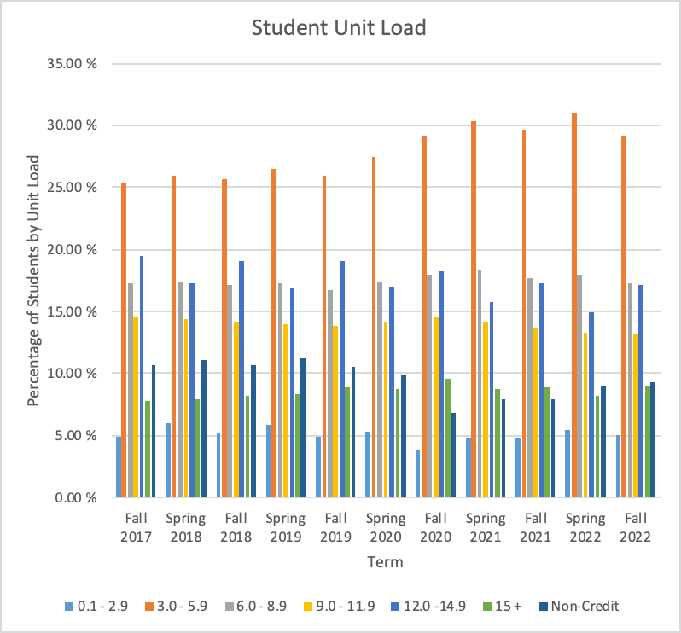

As colleges have implemented different types of support courses, the amount of attention some students are dedicating to a single course (with support) has increased. In addition, the “artificial” connection of completion to a calendar year and the connection to funding directly related to throughput challenges colleges to develop pathways that serve CCC students who are parents, working, or have other responsibilities, and those who might need to take fewer units to be successful.

“The version of throughput used for the Student-Centered Funding Formula was designed in that way in part to provide colleges clear incentives to help students enroll in and successfully complete trasnfer[sic]-level coursework in students’ first year, given the association between their early completion and longterm student achievement measures (and in part because of mundane limitations created by the misalignment of annual funding cycles with student attendance patterns).” https://www.cccco.edu/-/media/CCCCO-Website/About-Us/Divisions/Educational-Services-and-Support/AB705/equitable-placement-and-improvement-plans-faq-a11y.pdf

Colleges are incentivized to direct students to enroll full-time and complete pathways regardless of major, life circumstances, background, needs, or self-agency so the challenge remains to support the diverse needs of students while balancing the need to keep the college funded.

Overview of Resolutions Related to AB705:
We recognize and acknowledge that the faculty of the CCC system also share divergent views on AB705 and the implementation of the law. However, since the passage of AB705, AB1805, and AB1705, a large number of resolutions adopted by the delegates at ASCCC plenary sessions indicate faculty concerns over the legislation and implementation of the legislation with regard to student success, retention, persistence, and the impact of substandard grades in transfer-level coursework. Below is a table of the resolutions passed:

Plenary Session | Resolution | Title
Spring 2018 | 07.04 | Identifying Appropriate Assessment Measures
Fall 2018 | 05.02 | Identify and Report Costs of AB 705 (Irwin, 2017)
Fall 2019 | 05.03R | Assess How Alignment of Timeframes for AB 705 (Irwin, 2017) and the Student Centered Funding Formula for ESL Students Inequitably Impact Funding for Colleges Serving High Percentages of ESL Students
Fall 2019 | 07.04R | Convene the California Community Colleges Chancellor’s Office Assessment Committee for Credit English as a Second Language (ESL)
Fall 2019 | 09.09 | Ensuring Access and Opportunity for Success for All Students Through AB 705 (Irwin, 2017) Implementation
Fall 2020 | 18.01 | Paper and Resources for Evaluating Placement in English, English as a Second Language, and Mathematics Pathways
Spring 2022 | 03.04 | Expand Methods of Data Collection and Analysis to Fully Measure the Successes and Challenges of AB705
Spring 2022 | 06.04 | Students’ Right to Choose to Take a Pre-Transfer Level English or Mathematics Course
Spring 2022 | 06.05 | Regarding Chancellor’s Office Student Enrollment Data in AB 1705 (Irwin, 2022)
Spring 2022 | 09.02 | Co-Requisites and Pre-Requisites of Intermediate Algebra and Articulation and C-ID Alignment
Fall 2022 | 17.01 | Establishing an Equitable Placement and Student Success Liaison

Overview of the Paper:
- This paper presents the results from a survey of the impacts of AB705 on students. The intent of the survey was to learn about :
  - Placement, support, and college curriculum changes in response to AB705,
  - Preliminary reports on equitable success and persistence,
  - the impacts of the pandemic: withdrawal rates and success by modality, and
  - the impacts on equity and inclusion in business and STEM majors along with considerations of measuring equitable outcomes in courses and programs.
- We summarize prior publications related to AB705 implementation and provide data sources available to track AB705.
- Finally, we offer recommendations on what colleges can do to measure the impacts of AB705, while working to promote equitable outcomes for students in all demographic groups while maximizing student success, retention, and persistence; and minimizing students attaining substandard grades in transfer-level coursework.

Throughout this paper, we will be careful to distinguish between student success and throughput. In addition to examining what colleges have done to implement AB705, we will also include strategies colleges may want to consider to tackle unexpected challenges created by the passage of AB705.

ASCCC Spring 2022 Survey Data Collection Methods
In spring 2022, the ASCCC developed a survey consisting of 46 questions related to (among other topics) placement changes and data collection to measure the impacts on equitable student outcomes and administered it to the California Community Colleges via the ASCCC listservs. Several questions were designed with options for respondents to select, and some of these questions invited respondents to elaborate with written responses. We also asked several questions that were entirely free-response. Both quantitative and qualitative data are presented below. In many cases the qualitative response data are also presented as they reveal important trends and diversity in the answers we received. We identify trends in the qualitative responses, match similar responses by theme, and where appropriate, report the number of these similar responses .

Although the survey collected the respondent’s college affiliation and their role there, such data will be presented in aggregate form with no information to identify specific respondents or their colleges. Questions below are arranged thematically.

There were 59 respondents to our survey representing 39 colleges along with 10 anonymous respondents. Of the 39 colleges, 9 were from Area A (which encompasses the central valley and Northern California outside of the Bay Area), 9 were from Area B (which is mostly the San Francisco and Monterey Bay areas), 9 were from Area C (San Luis Obispo County and the greater Los Angeles area), and 12 were from Area D (the Inland Empire, Orange County, San Diego, and Southeastern California). To see which area a specific college is in, please use the ASCCC Directory (https://asccc.org/college_directory).

Respondents listed as the primary contact describe their role as faculty or department chair (26 respondents, of which 22 specifically list mathematics as their discipline), 10 from academic senate presidents, and 8 came from administrators or college researchers. At least 19 respondents represented collaborations of two or more individuals or offices.

i. Placement, support, and college curriculum changes in response to AB705
Placement:
The survey asked questions related to placement methods, including whether colleges were using default placement methods prescribed in CCCCO Memo AA 18-40 (cite: https://asccc.org/sites/default/files/AA%2018-40%20AB%20705%20Implementation%20Memorandum__0_0.pdf) followed by free-response questions asking colleges to describe how they determined whether corequisite support course placement was required for students.

The majority of survey respondents followed the CCCCO Guidance Memo AA 18-40 (https://www.cccco.edu/-/media/CCCCO-Website/About-Us/Divisions/Educational-Services-and-Support/AB705/AB705-2122/aa1840ab705implementation72018a11y.pdf) default placement recommendations based on high school GPA and prior coursework taken in high school. There were some nuances in terms of requiring corequisite courses, specifically two responses stated that students in BSTEM pathways with high school GPAs lower than 2.6 and their last math course was algebra 2 (sometimes also called “intermediate algebra” in high school) or math 2 enhanced (which is a realigned math curriculum that integrates concepts of statistics, geometry, algebra, and some trigonometry into a high school math course) (Source: https://www.cde.ca.gov/ci/ma/) were required to take a corequisite course.

Colleges were also asked to describe the types of multiple measures used to place students into transfer-level mathematics.

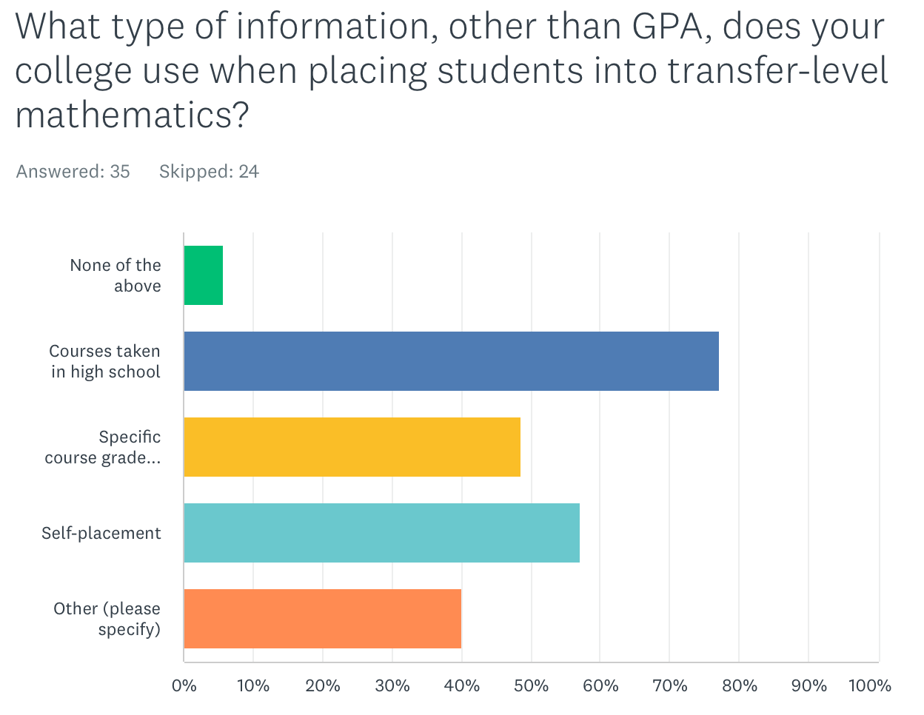
Colleges report that other methods such as self-placement are used in addition to course(s) taken in high school along with the grade attained in that/those course(s). As for the responses to “other,” responses included conversations with counselors and/or math faculty, challenge exams (or a prerequisite challenge process), and student’s declared major were reported as other criteria used to place students.

Guided Self-Placement
Questions related to placement practices included asking about colleges’ guided self-placement models. The majority of respondents (81.6%) have developed a guided self-placement tool or process. Respondents describe using guided self-placement for students who finished high school more than 10 years ago, graduated from a non-US accredited high school, received a GED, completed an adult education program (or high school proficiency certificate), or are currently enrolled as a high school student. Some colleges allow all students the option of guided self-placement. Respondents describe the information collected from their guided self-placement models as asking for the last high school course they completed. Some specify the final course grade in the highest-level math course completed and/or high school GPA. Some guided self-placement tools report considering the students’ major in placement. One college reports requiring the student to meet with a counselor to review the guided self-placement results and make placement recommendations. Several respondents report strongly encouraging students to meet with a counselor or math department faculty to review the placement recommendation.

Support Methods
The survey also asked questions about the types of support colleges were offering to students in transfer-level mathematics, and (if applicable) the type of support that colleges were requiring students to take along with transfer-level mathematics.

The types of support offered by colleges are shown in the figure below. The question allowed for multiple options to be selected, so colleges may offer one or more of the options.

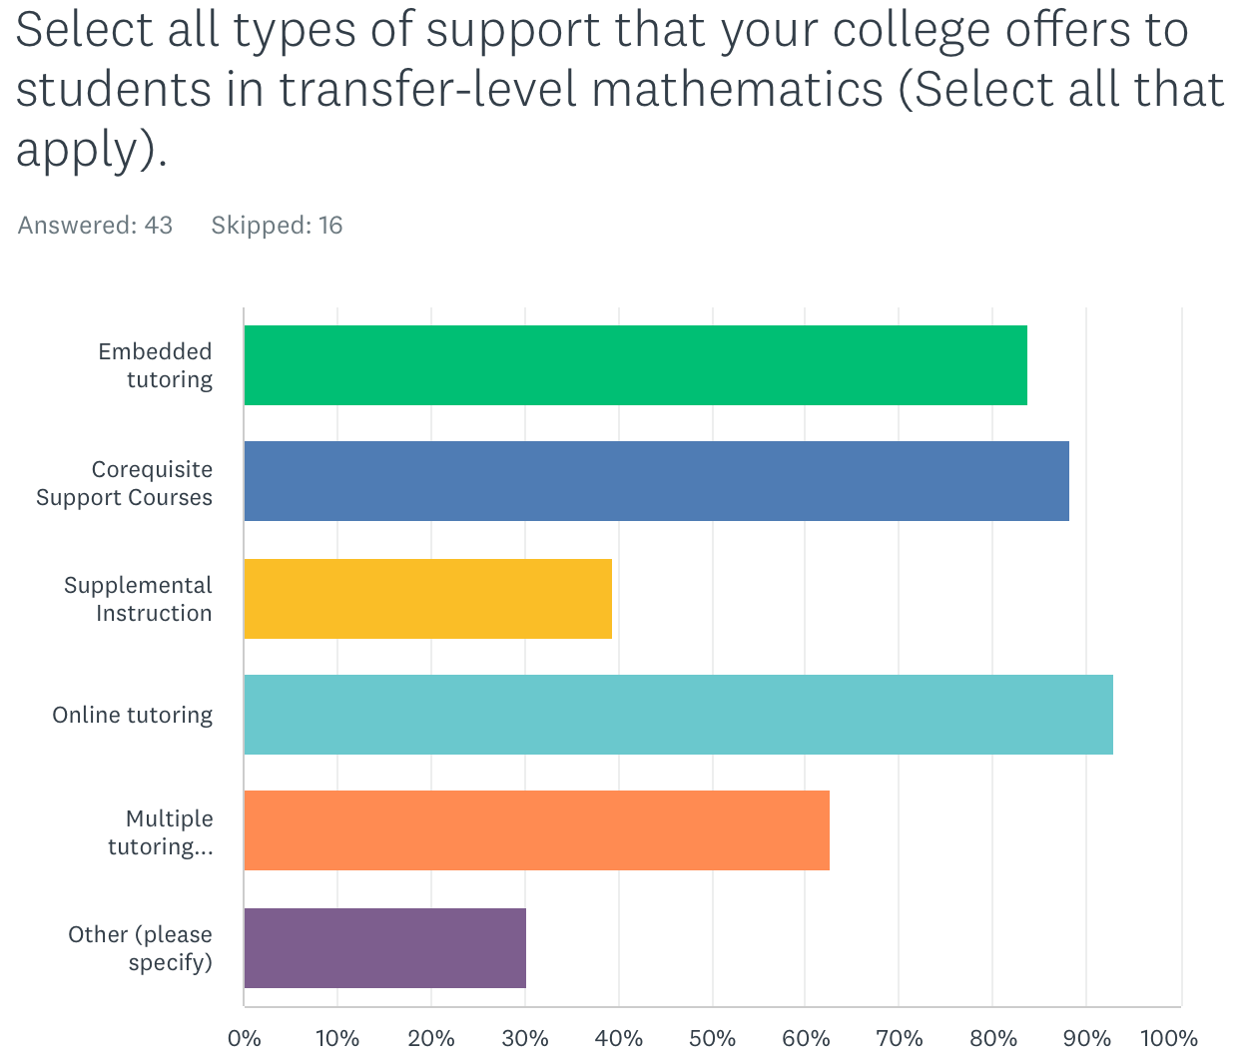

The majority of respondents offer tutoring in various formats and/or corequisite support courses. The responses to “Other” included the following: Math Lab, Math Center, or STEM Center with tutoring, supplemental instruction, or workshops, embedded counselors in courses, Student Success seminars in the weeks prior to the semester, linking some math courses to courses in other disciplines like counseling or reading, and the SPARK self-paced free module in Canvas.

Not all colleges require support for courses, but for those that do, 28% of respondents report requiring corequisite support courses. Corequisite support appears to be the most popular form of required support. The question does leave room for interpretation by colleges (as evidenced by the responses to “other” below), and the responses seem to imply that corequisite support courses are the most commonly required support for transfer-level courses.

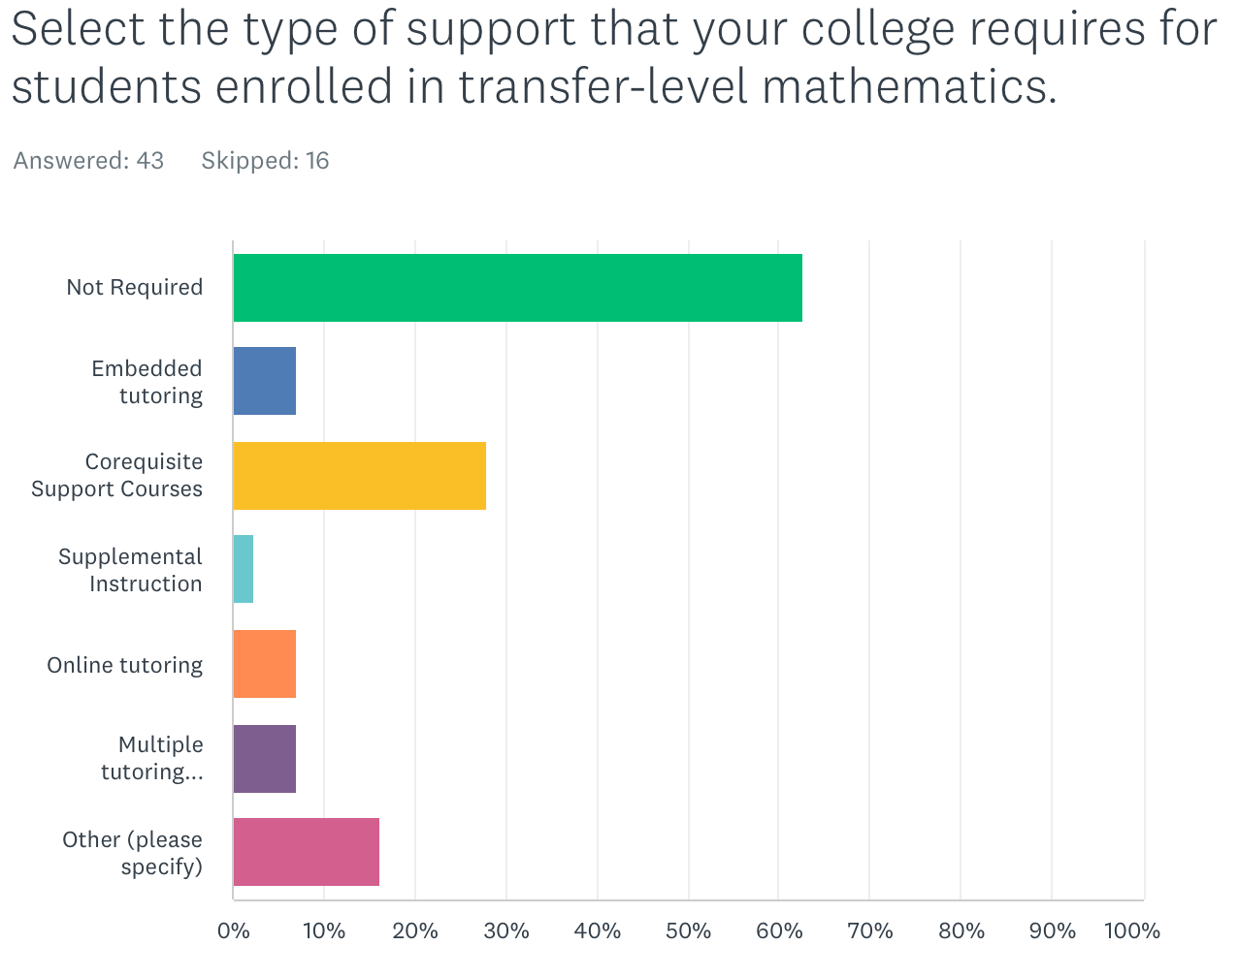

The responses to “Other” further explained the different corequisite courses that went along with SLAM or BSTEM placement. One response might have interpreted the “not required” choice as a blanket statement implying that no supports were required under any circumstances, and clarified that there are students who ere placed into courses without support but for those students who are placed into a course with required support, then there are supports offered. Another response stated that corequisite enrollment is only required if a student enrolls into a course with a corequisite, that is, a student must enroll in a parent course that also has a corequisite support course. One response stated that transfer-level courses were open for enrollment to all students, but not all sections had corequisite enrollment so corequisites were not really required. Aside from corequisite courses, two responses stated that support was available from a tutoring or success center. Additionally, one of those responses noted that COVID has disrupted in-person tutoring services.

Corequisite courses, when offered, were reported to be mostly credit courses associated with introductory transfer-level courses in statistics, quantitative reasoning, trigonometry, and college algebra. Typically, the corequisite is taught by the same instructor, and the course (co-requisite) meets after the parent course. The corequisite is typically structured to offer opportunities for students to practice and apply math basic skills. Nine respondents were also reporting corequisite support for pre-calculus (if that was the course into which students were directly placed) with no other lower-level math alternative listed for B-STEM students. Three respondents stated that their corequisite course was noncredit. One of those three respondents was exploring the possibility of credit corequisite options. Twelve respondents implied that corequisite support was available in upper-level math courses beyond the introductory transfer-level B-STEM course. Four respondents noted corequisite support only for statistics and no other math or quantitative reasoning courses.

AB1187 (Irwin, 2022) (https://leginfo.legislature.ca.gov/faces/billTextClient.xhtml?bill_id=202120220AB1187) was recently-passed allowing colleges to collect apportionment for supervised tutoring in foundational skills and transfer-level courses. It’s likely that more tutoring resources will be used to support students in their first math/quantitative reasoning course. While this law presents a good opportunity to diversify and augment support for students, it will also be important to collect data on the effectiveness of supervised tutoring or embedded tutoring in courses. Is access to tutoring equitable, and can students find the time to access tutoring? Are the benefits equitable, and are equity gaps being eliminated?

Curriculum Changes:
Recognizing that there are many types of transfer-level mathematics courses, we also surveyed colleges on the types of transfer-level mathematics or quantitative reasoning courses colleges offered and which non-math departments offer GE courses that meet CSU-GE Area B4 and IGETC Area 2. We also asked which of these courses were newly developed post-AB705. The most popular answers were statistics for psychology, sociology, social sciences, or business. Some respondents reported increased numbers of sections being offered in these discipline-focused statistics courses and that the majority of these courses existed at the respondents’ colleges pre-AB705. Other examples of GE courses that were not statistics were in the computer science, industrial technology and business/economics disciplines. With the implementation of AB928 (Berman, 2021) which requires a “singular lower division general education pathway” to determine transfer eligibility to both CSU and UC, colleges will need to continue to monitor student interest in these courses and continue to ensure that the course offerings continue to meet student needs for their educational goals.

ii. Preliminary reports on equitable success and persistence,
To assess the impacts of placement, we asked about the percentage of students who enrolled in a mathematics course for a second time after they did not successfully pass transfer-level mathematics in their first attempt. The majority of survey respondents did not reply to this question. It is possible that these data may not be readily available, and therefore the question was skipped. For example, of the responses that were provided, 12 specifically indicated that they either didn’t have access to this information or their college is not tracking this information. Seventeen respondents had some quantitative response to the question, but the amount of information varied greatly. For example, some responses specified the term(s) from which the data were obtained, or whether or not the students successfully passed a course with or without a corequisite. Of the 17 respondents who cited quantitative data on students who re-enroll, the re-enrollment rates range from 24% to 62% with the following breakdown: 24-30% (5 respondents), 30-40% (6 respondents), 40-50% (4 respondents), 50-60% (1 respondent), and above 60% (1 respondent). The majority of respondents report fewer than half of students who do not pass transfer-level math initially re-enroll for a second try. It will be important for colleges to disaggregate these numbers by race/ethnicity and disproportionate impact status to look for equity gaps in student completion and students re-attempting a course after initially not passing. We also recommend that we learn more about the enrollment and persistence patterns of students. Current data collection methods and reports do not count the numbers of students who do not enroll in a math/quantitative reasoning course. Our data collection methods also do not compare student drop data before and after census. The focus on throughput also ignores questions about disproportionate impacts on students not passing classes that may have resulted from new placement practices. Some colleges or districts may collect student response data to questions asking why they are dropping courses. Such qualitative data could be more broadly collected and systematically analyzed to learn about how to better-support the students who are not succeeding. Our system Chancellor’s Office can effectively partner with ASCCC to advocate that we find and report on the successes of AB705/1705 and also use qualitative and quantitative data to improve outcomes for all students, but especially disproportionately impacted populations.

A follow-up question in our survey asked whether colleges disaggregate the data to identify student groups who are less likely to enroll in a second attempt following a first attempt. Twelve respondents highlight/stress the needs for local flexibility in placement processes as adverse impacts still are seen on disproportionately impacted student groups. In addition, they highlight the need to amplify the message to students to persist after an unsuccessful attempt. Respondents report that Latinx, Native American, Pacific Islander, African American, first generation, 18-19-year olds, students older than 30, male students, non-athletes, part-time students, multi-racial/ethnic, first-generation, and life-long learning students are less likely to re-attempt transfer-level courses after having failed them. Methods of identifying disproportionate impact are reflected in the results. For example, one response reports male students, American Indian, African American, Pacific Islander, Latinx and white students were less likely to re-attempt compared to Asian students. A popular method of measuring disproportionate impact is the percentage point gap index minus one (PPG-1) method (https://www.cccco.edu/-/media/CCCCO-Website/About-Us/Divisions/Digital-Innovation-and-Infrastructure/Research/Files/PercentagePointGapMethod2017.ashx). It is also clear that methods of disaggregating with a focus on racial equity are also important to consider. One college disaggregated by whether students were in a stand-alone course versus a course with a corequisite and noticed that students were equally likely to re-attempt regardless of whether the course had a corequisite, and the pass rates on the second attempt were equal to the first attempt. The response, however, did not disaggregate by student group aside from the course they were in.

Finally, the Student-Centered Funding Formula (SCFF) incentivizes colleges to enroll all students in transfer-level math within an academic year regardless of a student’s starting term. Our survey asked about whether and how the SCFF incentives has impacted instruction. We received four responses that indicated an impact of the student-centered funding formula on student outcomes. The lack of consensus within a small number of responses, warrants further study. The quantitative data, when considered in aggregate, from one college reported increased numbers of students successfully completing math within one year. These increased numbers largely reflect the statewide average trends that result from higher numbers of students being placed in transfer-level coursework. Anecdotal data from another respondent show a drop in student readiness as evidenced by a lower percentage of students passing their first pre-calculus exam after changes to student placement were implemented. This respondent also highlights a subsequent negative impact on the morale of both the instructor and students.

iii. the impacts of the pandemic: withdrawal rates and success by modality
The survey was administered as most colleges were initially transitioning out of remote operations. To assess the impacts of COVID, colleges were asked whether comparisons of successful math completion were drawn between in-person and online instruction pre-COVID. Below is a graph depicting the responses. A follow-up free-response question allowed colleges to describe the differences in success rates by modality.

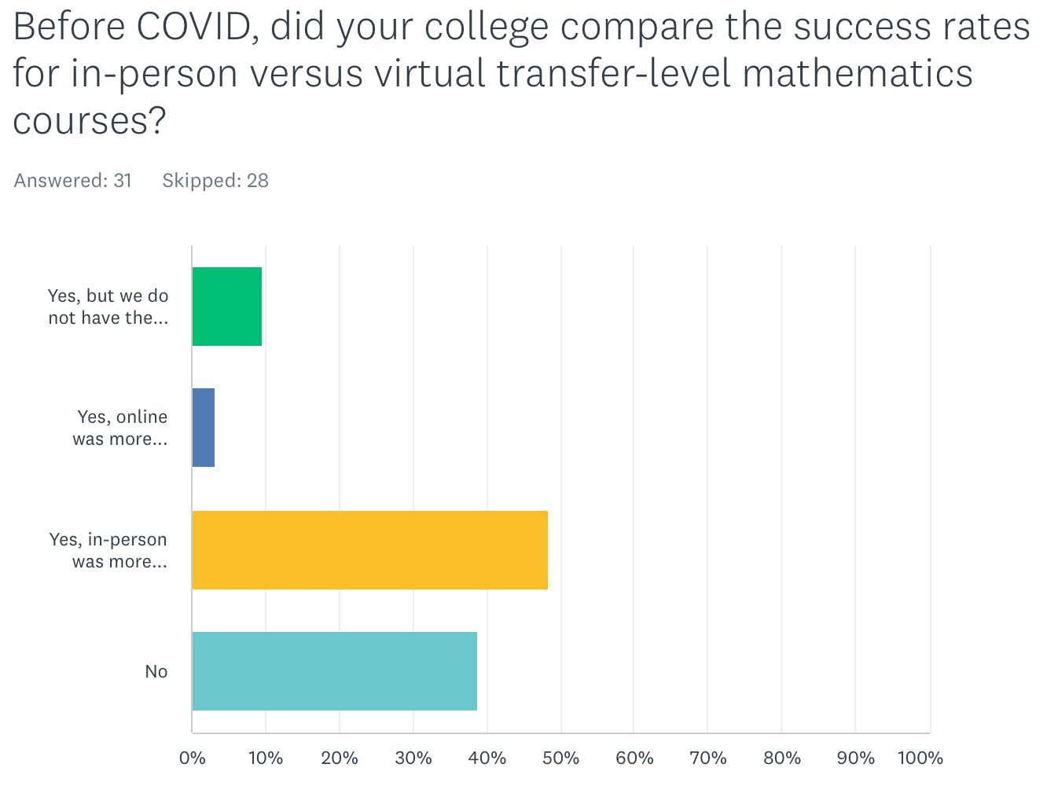

Of the respondents that had data to share, the in-person modality was reported to be much more successful than the online modality. Respondents self-reported their course success rates, and 15 responses were submitted that allow comparison of in-person to online success. One of the 15 reported a higher success rate in online courses. One represented a range of success over terms, with success rates varying over seven percentage points over four years and with no clear pattern of higher success in one modality versus the other. For all other responses, in-person success rates ranged from 6% to 20% higher than online instruction.

We surveyed withdrawal rates pre-COVID and during COVID. Responses ranged from 14 to 36% withdrawals from transfer-level math courses pre-COVID. Comparing the withdrawal rates during COVID to pre-COVID, eleven respondents reported a higher withdrawal rate during the pandemic than pre-COVID. Seven respondents reported the same or lower withdrawal rate during the pandemic than pre-COVID. One of the limitations of this survey was that the question did not specify whether to include or exclude excused withdrawals from the numbers. One of the provisions of the pandemic was an emergency declaration that access to emergency withdrawals was expanded, and CCC funding would not be affected by emergency withdrawals. It is possible that our survey respondents did not consistently include or exclude emergency withdrawals from the total number of withdrawals.

For colleges that offered a blend of synchronous and asynchronous remote instruction during the pandemic, we asked whether there was a difference in success rates in each case.

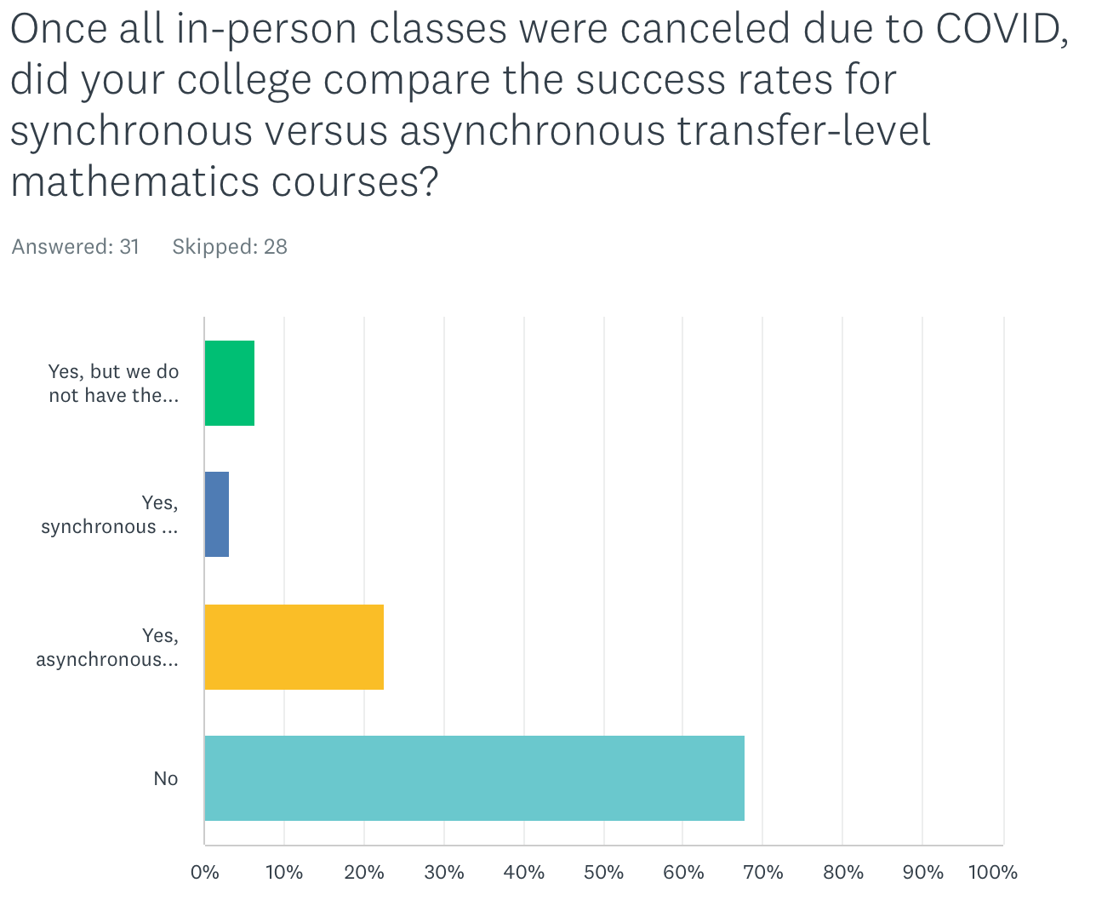

Most respondents reported not comparing the success rates in asynchronous versus synchronous online courses after classes were largely moved to remote instruction during the pandemic. Of those respondents that were able to research the differences, more respondents (seven compared to one) reported higher success in asynchronous online instruction. The one respondent reporting higher success in synchronous online instruction showed a difference of 24 percentage points over success rates in asynchronous online instruction. For those respondents with higher success rates in asynchronous courses, the differences ranged from less than one percent to 7.5 percent when presented in aggregate. These success rates in synchronous versus asynchronous rates were also not disaggregated by student group, so an unresolved question of whether there are any equity gaps in student success in either online or remote instruction modality remains.

iv. the impacts on equity and inclusion in business and STEM majors along with considerations of measuring equitable outcomes in courses and programs.
We asked colleges to assess the impact of AB705 on Business and STEM (B-STEM) pathways and student participation in B-STEM majors. We obtained 19 responses to the question.

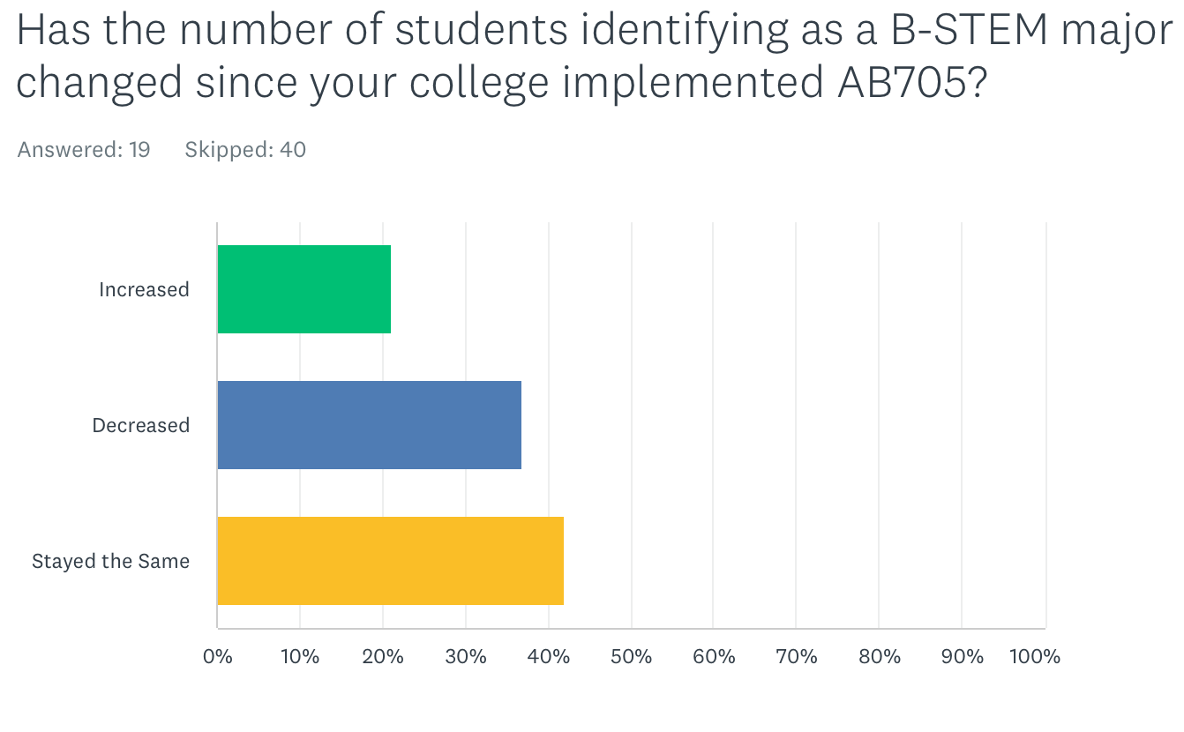
Four reported an increase, seven reported a decrease, and eight reported no change. Interpreting these trends would require follow-up studies to ask students if and how placement into math affected their choice of major. It is also possible that there is no effect (positive or negative) of AB705 on students choosing a major. For many colleges, a student indicates a major (or metamajor/area of focus) first, and that initial choice then guides the student to an appropriate math class. An initial report of student majors pre-enrollment is an important data point to collect. It is important for colleges to continue to monitor persistence in B-STEM majors compared to that initial data point.

While many students enter college with an idea of their major or general interests, we must also recognize that many students do not know their major upon entering community college. It is important for instructional faculty and counseling faculty to work together on appropriately guiding undecided students to select the correct first math course that (where appropriate) leaves options open.

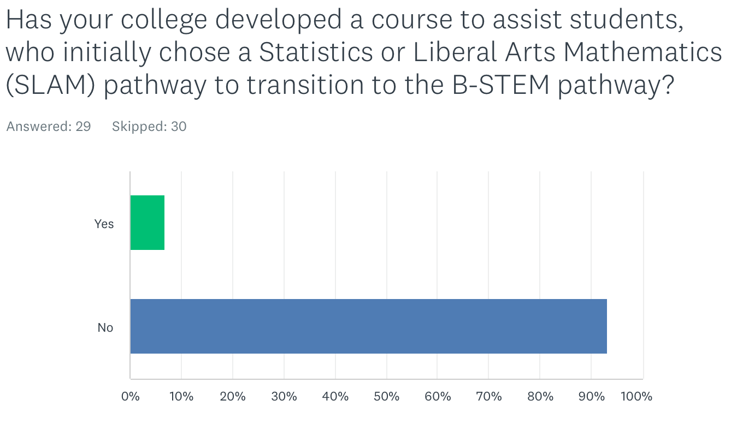
When asked whether there is or will be a bridge course developed that allows students to change from the Statistics and Liberal Arts major (SLAM) pathway to the B-STEM pathway, two respondents reported a bridge course that would support student transitions from the SLAM pathway to the B-STEM pathway. One respondent shared that it was a college algebra course. The other respondent also had a college algebra class along with a corequisite to support basic algebra skills if students need it to transition from the SLAM math course to business calculus. The other survey respondents either did not answer the question or confirmed that no such bridge course exists.

Supporting student exploration into B-STEM pathways even after they might have started on a different college pathway is an important mission of higher education. Moreover, there is an equity imperative to expanding access to B-STEM majors and supporting Black/African American and Latina/o/x students in pursuing these majors where underrepresentation in academic fields further widens societal and systemic gaps in healthcare, scientific literacy, and leadership opportunities in the corporate and political arenas. Colleges must continue to use local research data to identify equity gaps in student access to B-STEM pathways regardless of where they are in their education.

We asked about whether and how the number of students identifying as B-STEM majors has changed, and whether the demographics of B-STEM majors has changed post-AB705. Responses to our survey highlight the fact that most college constituents do not know if the demographics of B-STEM students has changed after the implementation of AB705.

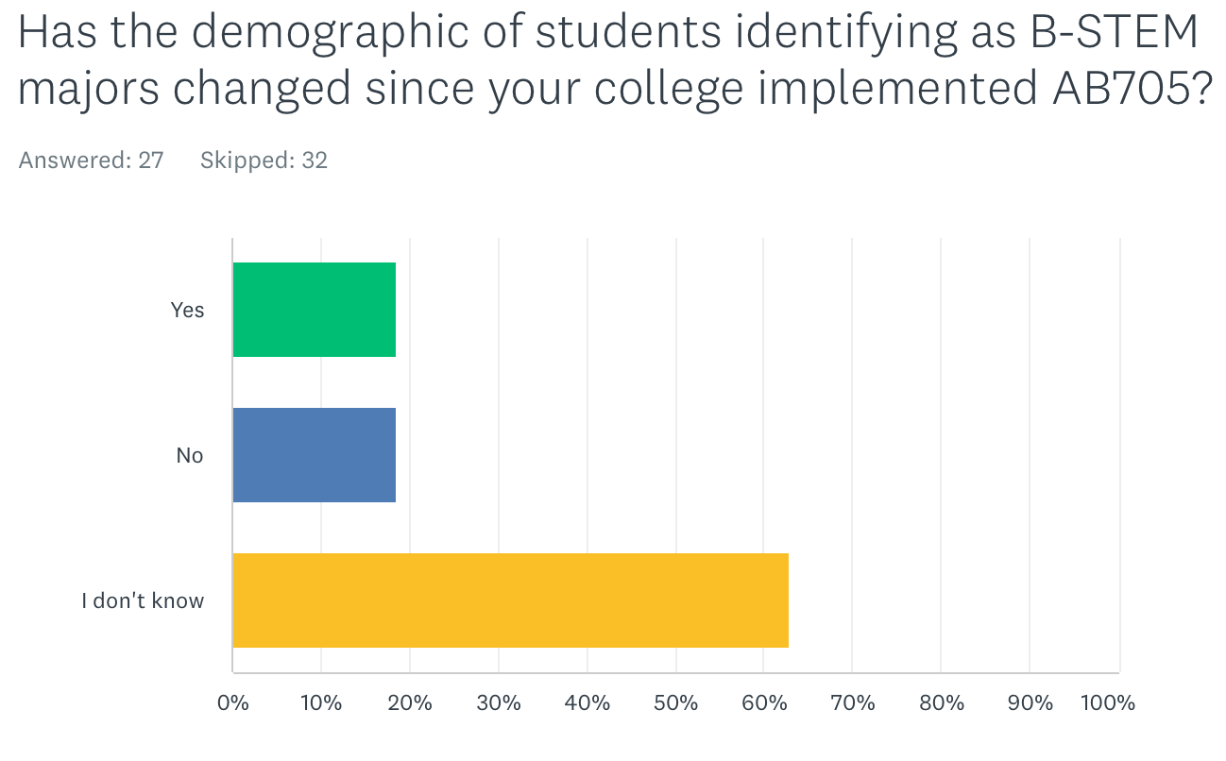

For those respondents who did know, five said that the demographics have changed while five said that the demographics did not change. The follow-up question asking to describe the demographic changes report that the percentage of female students is increasing and the number of incoming students declaring a B-STEM major has increased. Three other respondents reported decreases in a variety of student categories. Notably, among the three respondents the following student demographic groups were cited by one or more respondents: African American, Latinx, Filipino, Pacific Islander, female, first generation, and economically disadvantaged students.

We asked about the prevalence of intermediate algebra as an offering and as a prerequisite. We also asked whether a college plans to continue requiring intermediate algebra before a student enrolls in transfer-level math. As of Spring 2022, 78% of respondents reported offering intermediate algebra. Note that this may not be a representative number of the CCC system as a whole, and it’s unclear whether this percentage might have decreased in Fall 2022 and beyond. Title 5 55063 (Cite: https://govt.westlaw.com/calregs/Document/I43B642004E0E11EDA19AD993669B28BD?viewType=FullText&originationContext=documenttoc&transitionType=CategoryPageItem&contextData=(sc.Default)) sets intermediate algebra as the minimum level of math proficiency to earn an AA/AS degree from a CCC. While Title 5 has not changed, AB1705 figures to de facto increase the math competency standards to graduate from a CCC with an associate degree for most students. The latest CCCCO Memo ESS 22-400-009 (https://www.cccco.edu/-/media/CCCCO-Website/docs/ab705/ess22400009ab1705implementation122322a11y.pdf) specifies limited circumstances where a pre-transfer-level course may be offered to students, namely that such a course is explicitly required by an outside accreditation agency or the program advisory board and the requirement cannot be met with a transfer-level course..

Although AB705 requires colleges to adjust how students are placed into transfer-level courses, the law did not explicitly require changes to prerequisites. Our survey responses suggest that many colleges might have removed or adjusted prerequisites on transfer level courses as a result of AB705. In light of the CCCCO Memo AA 18-40 (cite: https://asccc.org/sites/default/files/AA%2018-40%20AB%20705%20Implementation%20Memorandum__0_0.pdf), half of the respondents that require intermediate algebra (or high school algebra II) as a prerequisite to B-STEM courses will no longer require intermediate algebra as a prerequisite, presumably this means that curriculum has been changed to no longer require intermediate algebra or algebra II explicitly. The survey responses reported 68% of respondents no longer requiring intermediate algebra (or high school algebra II) for students in B-STEM pathways entering their initial transfer-level math course, and this higher percentage may be the result of some colleges eliminating or no longer offering intermediate algebra as of Spring 2022. Some colleges are placing B-STEM students into college algebra, which is a transfer-level course that, if completed, would also meet the intermediate algebra requirement.

Our survey asked follow-up questions on how these changes in course sequencing (i.e. the relaxing or elimination of prerequisites or direct placement into transfer-level courses) may affect students. A follow-up question asked whether the first enrollment success rates in transfer-level courses with intermediate algebra as a prerequisite have changed since the implementation of AB705.

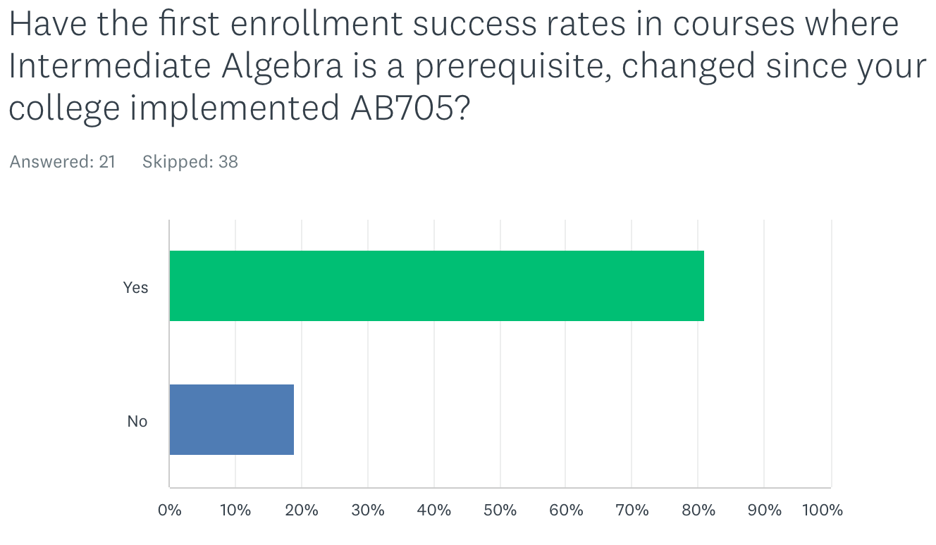

Of the 21 responses, 81% said that the first enrollment success rates have changed. Most respondents reported anecdotal evidence that success rates have fallen. Consistent with statewide trends where more students are being placed into transfer-level math or quantitative reasoning, one response reported that enrollment in courses that had intermediate algebra as a prerequisite has increased post-AB705 both in quantitative reasoning courses and in disciplines such as biology, chemistry, economics, and psychology where some courses (due to articulation requirements to transfer institutions (Citation: https://www.ucop.edu/transfer-articulation/transferable-course-agreements/tca-policy/regulations-by-subject-area.html ) have also had intermediate algebra as a prerequisite. Some respondents also reported shifts in course offerings with decreased (or eliminated) pre-transfer-level math courses and/or increased statistics offerings compared to pre-AB705 when more business and STEM focused math courses were offered.

As curriculum in B-STEM pathways typically requires a sequence of math courses and preparatory math courses establish a foundation for success in higher-level math courses, we asked whether colleges track the success of math sequence completion in B-STEM majors.

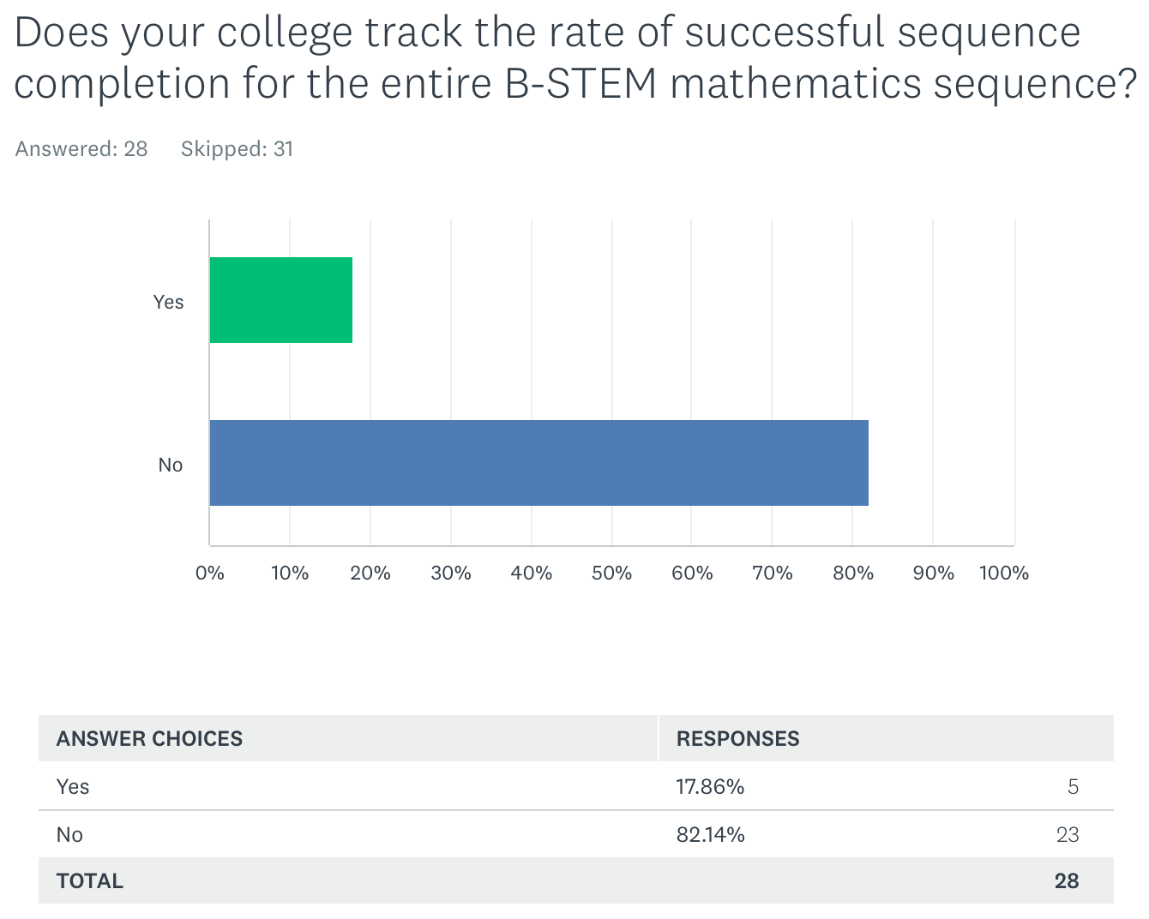

Five respondents reported tracking the rate of successful completion of the entire B-STEM math sequence. Details of their responses are as follows: Two shared their colleges’ results or how they measured success, one showed a 16.5 percentage point drop in success post-AB705 while another reported success rates as the percent of B-STEM majors who earn their certificate, degree, or transfer. Recognizing that the initial AB1705 guidance from the CCCCO calls on colleges to validate transfer-level prerequisites (https://www.cccco.edu/-/media/CCCCO-Website/docs/ab705/ess22400009ab1705implementation122322a11y.pdf), it is important to continue to document success rates in math sequences, measure the persistence and success rates of students intending to major in B-STEM disciplines, and monitor for equity gaps. The last part, monitoring the effects on equity gaps is of critical importance.

To maintain transferability (particularly to UC) and articulation (with C-ID and major prep articulation), some courses in disciplines such as economics, biology, and chemistry are required to have prerequisites of algebra or intermediate algebra. Where colleges are reducing or eliminating pre-transfer-level math courses, student quantitative reasoning skills in disciplines outside of mathematics may impact student course-taking patterns and/or success. Some colleges are offering support for students in these other than mathematics disciplines that have intermediate algebra as a prerequisite. Examples cited by three survey respondents reveal that such supports were all for chemistry classes. The support classes are designed to help with calculations in chemistry, and in one case, the support course existed prior to the implementation of AB705.

The passage of AB1705 and the law’s focus on the calculus preparatory sequence will challenge colleges and districts to continue to collect data on student placement and persistence through the prerequisite sequence into Calculus 1 and Calculus 2 (if a program requires Calculus 2). Prerequisites are instituted not as barriers but as tools to promote student success in higher-level courses. While we must continue to validate prerequisites, evaluate, and adjust curriculum through an equity lens, so too must we continue to evaluate the success of initiatives on student access and success both at the course and program level also through an equity lens.

To graduate from high school in California, the minimum level of math proficiency is elementary algebra (Citation: https://www.cde.ca.gov/ci/gs/hs/hsgrmin.asp). The table below summarizes the minimum requirements to graduate from a public high school in California compared to the minimum course eligibility requirements to be admitted to the CSU or UC as a freshman admit. Except as indicated, each course is one year of high school.

Subject | HS Diploma | Freshman CSU admission | Freshman UC Admission
A. Social Studies | 3 courses including one year each of US history and world history/culture/geography, and one semester of US government and economics | 2 courses including a year of US history or US history/government and a year of world history/culture/geography | 2 courses including a year of US history or US history/government and a year of world history/culture/geography
B. English | 3 courses | 4 courses | 4 courses
C. Mathematics | 2 courses including one year of Algebra 1 | 3 courses including algebra, geometry, an intermediate algebra; 4 years recommended | 3 courses including algebra, geometry, an intermediate algebra
D. Science | 2 courses including biological and physical sciences | 2 courses including lab courses in biological and physical sciences | 2 courses including lab courses in biology, chemistry, and physics; 3 years recommended
E. Foreign language | 1 course | 2 courses in the same language | 2 courses in the same language
F. Visual / Performing Arts |  | 1 course | 1 course
Career technical education |  | N/A | N/A
G. College Preparatory Elective |  | 1 course | 1 course
Physical Education | 2 courses | N/A | N/A

In addition, students earning a “D” grade in high school courses receive credit towards graduation, but students headed to UC and CSU must complete the a-g requirements with grades of “C” or better. The requirements to be admitted to the UC or CSU out of high school exceed the requirements to graduate from high school. Of note, the math requirement for admission to UC and CSU (intermediate algebra or algebra 2) is higher than the minimum requirement to graduate from high school (algebra 1). The California Department of Education DataQuest cohort report of 2021-22 high school graduates shows data disaggregated by race/ethnicity showing high school diploma completion rates along with the disaggregated numbers of students who met the a-g requirements to be eligible for admission to the UC and CSU (Citation: https://dq.cde.ca.gov/dataquest/dqcensus/CohRate.aspx?cds=00&agglevel=state&year=2021-22). The data show equity gaps in high school diploma attainment in Black/African American, American Indian or Alaska Native, Hispanic or Latino, and Pacific Islander students. Overall 51.4% of the 2021-22 high school graduates met the a-g requirements for admission to UC/CSU, but the same student groups with lower levels of high school diploma attainment also have below average numbers of students who met a-g requirements for admission to CSU and UC.

Given that there are discrepancies between the standards for graduation and the a-g requirements for transfer, the CCCs represent an important bridge for those students to access higher education. The UC system has recently initiated a program whereby high school students who were not eligible for UC admission due to not having met the a-g requirements could be guaranteed admission to UC after completing those requirements plus requirements to be admitted with a Transfer Admission Guarantee (TAG) at a CCC (https://www.universityofcalifornia.edu/news/new-dual-admission-pilot-program-will-help-more-students-transfer-uc). For these students, it is up to the CCCs to offer a high-quality education to be successful in the courses to fill unmet a-g requirements and the transferable CCC courses required for admission as a transfer student to UC. It should be noted that precalculus is the introductory level course for Business or STEM majors at UC, and most UCs admitting students as a Business or STEM major will require those students to have completed most or all of their math at a CCC. So for students in the UC dual admission pilot program aspiring to be business or STEM majors, the community colleges must be able to provide courses to support those students’ persistence through the CCC and prepare students well to be successful in their majors at UC. Still, questions persist about why students graduating high school are not eligible for admission to CSU and UC. It is possible that systemic barriers to access a-g courses may still exist where some high schools do not offer one or more courses to meet the a-g admission requirements.

Now that AB1705 has been signed into law, colleges’ ability to offer Intermediate algebra is greatly reduced especially for students in B-STEM majors. Per CCCCO Memo ESS 22-400-009 (https://www.cccco.edu/-/media/CCCCO-Website/docs/ab705/ess22400009ab1705implementation122322a11y.pdf) students must be placed into transfer-level courses except under limited circumstances where an accrediting agency or advisory board specifically requires a pre-transfer-level quantitative reasoning course and a transfer-level course will not meet the requirement. In light of the above information about student access to math in high school and high school graduation requirements, devising ways to maintain equitable access and promote equitable student success in B-STEM majors will be a challenge colleges face. We must keep in mind that the students we serve come from diverse educational backgrounds including students who did not graduate from high school and/or come to us with adult school credentials. Many of our students are returning to school after a significant gap in their education including veterans, and many of these students are intending to major in Business or STEM. For students seeking more solid foundations in math, maintaining access to and support in diverse course offerings are key to advancing equity in the Business and STEM disciplines. Moreover, diversity in the curriculum aligns with the mission of community colleges as open-access institutions.

Recognizing that colleges may have developed local methods of identifying and tracking equity gaps in transfer-level math, we surveyed to see whether they have gone beyond the data disaggregation required by the CCCCO’s Student Equity and Achievement (SEA) Program. Our survey asks them to describe how they track those gaps and explain whether AB 705 has impacted their tracking methods.

Many respondents report following the SEA metrics. The table below summarizes some of the ways that colleges are disaggregating data. Items in bold had more than three responses.

- Gender
- Ethnicity
- Socioeconomic status
- DSPS
- 1st generation
- Foster youth
- Age
- Veterans
- AB540
- EOPS
- English language learner
- Athlete
- Promise grant
- Full-time/part-time
- Residency
- International student
- Dual enrollment
- Rising scholars
- Additional gender identities
- Educational goals
- High school GPA
- Placement
- Enrollment after placement
- Support course enrollment
- Start course first attempt success
- Online/in-person
- Learning Community
- Course session length

As for the impacts of AB705 on the types of data that were collected, colleges are collecting data on access, throughput, success, and withdrawal rates disaggregated by the above criteria (where possible). Faculty have varying levels of access to and interest in data collection. In mathematics and quantitative reasoning, in particular, there is likely to be greater faculty buy-in if there is agency and involvement of faculty in data discussions related to measuring student success. It can be beneficial to work with faculty to find ways for them to provide input on data collection and analysis and then use their findings to work with their departments, colleagues in other departments, local college Academic Senates and administrators to make improvements as needed.

Given the imperative to maximize the probability that a student enters and completes transfer-level math within one year, it is important to get a full view of the impacts of AB705 on our diverse student population. Data disaggregation is therefore key to collecting quantitative data. Understanding students’ unique experiences and needs pre-college and during college can come from qualitative data. Faculty are in the best positions to design questions that probe at and surface students’ experiences at our colleges so that we can address their needs. Therefore, our colleges and system will need to support faculty and our college researchers in these data collection efforts.

Transfer-level meaning applicable to the California General Education Transfer Curriculum (Cal-GETC)? An unresolved question
AB1705’s passage along with the passage and implementation of AB928 will create further complexities for colleges. Cal-GETC, recently adopted by the Intersegmental Council of the Academic Senates (ICAS) will be ”the only lower division general education pathway used to determine academic eligibility and sufficient academic preparation for transfer admission to the California State University and the University of California” (https://leginfo.legislature.ca.gov/faces/billTextClient.xhtml?bill_id=202120220AB928). It should be noted that not all majors or colleges at a single UC or CSU campus will require or prioritize GE completion as a criterion for admission, and these colleges (e.g. colleges of engineering) may have unique GE patterns that do not align with the proposed Cal-GETC. CSU-GE will remain as the GE pattern used by CSU for students entering as freshmen.

Many quantitative reasoning courses (for example courses in personal finance) that were applicable to CSU General Education Breadth Area B4 are not UC transferable. UC Transferability is a prerequisite to being considered for approval for any IGETC area. Thus, there are some courses that are currently applicable to CSU GE Breadth Area B4 but are not approved for IGETC Area 2A. Presumably any course applicable to Cal-GETC would also have to be UC transferable. The UC Transferable Course Agreements (TCA) document specifically lists courses in courses in “financial mathematics” or “consumer mathematics” as not meeting eligibility for UC transferability (https://www.ucop.edu/transfer-articulation/transferable-course-agreements/tca-policy/regulations-by-subject-area.html#m). The most recent IGETC standards from 2022 specifically list courses in “symbolic logic, computer programming, mathematics for teachers, and survey courses such as in math in society” as not meeting the IGETC requirements that a quantitative reasoning course “focus on quantitative analysis and the ability to use and criticize quantitative arguments” (https://icas-ca.org/wp-content/uploads/2022/06/IGETC_STANDARDS-2.3_02June2022-Final.pdf). It is possible that there will be fewer options for transfer-bound students to complete quantitative reasoning courses to meet GE requirements in the community colleges as there are courses in personal finance, consumer mathematics, symbolic logic, mathematics for teachers, and math in society courses that meet CSU-GE breadth criteria, but are not approved for UC transfer or IGETC Area 2A. The implementation of Cal-GETC also figures to narrow curricular offerings (e.g. fewer contextualized mathematics courses will be applicable for transfer as part of the transfer GE pattern compared to the CSU-GE Breadth pattern that CSU students entering as freshmen will follow), so where colleges had robust options for students previously, studying the impacts of reduced options on student enrollment, persistence, and program completion or transfer may be beneficial.

Community colleges may want to continue to support student exploration to equitize the learning experiences of CCC students to their counterparts at UC/CSU. Many higher education students change their majors and education goals and their academic, personal, and career interests need to be supported. Colleges may want to research how often students might switch from SLAM or CTE to B-STEM majors. We need to also recognize that although the CCC system also serves a different population than the CSU and UC, curricular offerings at CCCs need to (at a minimum) match what is available to CSU students (including trigonometry and college algebra). Though we must also be aware of the need to offer foundational courses that will support students who need the extra help. Reduced placement options and removing student agency to seek the help they need by narrowing course options or enrollment options makes assumptions that our students come to us with fairly equal access to preparatory coursework.

In addition, AB1705’s passage has meant that the focus now is on placing and ensuring students enroll into transfer-level and according to the CCCCO Memo ESS 22-400-009 (https://www.cccco.edu/-/media/CCCCO-Website/docs/ab705/ess22400009ab1705implementation122322a11y.pdf) for B-STEM majors, placing students into degree-applicable courses. The memo states that colleges must show that placement into prerequisite courses lower than the degree-applicable course will improve success in courses like Calculus 1 and also improve chances that students will continue to and pass Calculus 2 (if required). The challenges for colleges will be to understand the educational backgrounds of students and have discipline faculty develop innovative curriculum to support students and counselors collaborate to provide effective guidance regarding student placement. Faculty will need to work with institutional research offices to devise research questions to monitor the effectiveness of existing and proposed placement innovations.

Overview of Other Papers Showing AB 705 Outcomes:
After AB705 was enacted, a number of studies reporting throughput data and placement data were published by the Research and Planning (RP) Group and the Public Policy Institute of California (PPIC).

The RP Group Study, “Transitions in Math from High School to Community College Before and After AB705, Updated through Fall 2021” reports on enrollments in math pre-AB705 resulting in higher numbers of students re-taking the college version (or a lower level) of a math course taken in high school with higher percentages of Black/African American, Latina/o/x, and Native American students represented in the students who were enrolled in a college course with the same title (or lower) than the highest high school course completed. Additionally, the study presents an analysis of CalPASS data showing student success rates in their initial college math course as a function of the highest math course a student completed in high school. The study presents data from Fall 2016 and Fall 2021 showing that success rates for students who took Algebra 2 in high school were approximately the same in 2016 if those students took intermediate algebra or statistics in college, or slightly higher success in statistics compared to intermediate algebra in 2021. If we assume that courses like Algebra 1 or Integrated Math 1 and Algebra 2 or Integrated Math 2 are roughly equivalent to Elementary Algebra or Intermediate Algebra in college, the study could be interpreted to suggest that the highest success rates were seen in students who repeated a course one or more levels below the course the student completed in high school. (https://rpgroup.org/Portals/0/Documents/Projects/MultipleMeasures/AB705_Workshops/Transitions_in_Math_From_HS_to_CC_Before_and_After_AB705_January2023.pdf?ver=2022-12-30-074239-157)

In December 2021, the Public Policy Institute of California (PPIC) wrote “Community College Math in California’s New Era of Student Access.” https://www.ppic.org/publication/community-college-math-in-californias-new-era-of-student-access/ The article reports an increase in the rates of successful math completion in one term in fall 2020 compared to fall 2019 (46% vs 40%, respectively), and higher numbers of single-term transfer-level completion compared to fall 2018 (reported at 24%). It’s important to note that the reported successful completion rates were all under 50%. Additionally, the low percentage rate in fall 2018 could be due to students enrolling in courses below transfer level, so it would not be possible for such a student to complete transfer-level coursework in a single term. The study also reports on disproportionate impacts on Black/African American and Latina/o/x students both being more likely to be enrolled in below-transfer level courses and one fifth of Black/African American and Latina/o/x students were completing transfer-level coursework the following fall semester. The study also reports Fall 2019 data on non-traditional-aged students who were more likely to have used guided self-placement, which will no longer be permitted under AB1705, were almost 9% more likely to pass transfer-level math in a single term. Moreover, the same analysis shows that Black/African American, Latina/o/x, Native American, Pacific Islander, and Foster Youth are 12.6%, 8.6%, 7.6%, 8.2%, and 6.7% less likely to pass transfer-level math in a single term suggesting that there are persistent equity gaps seen in the initial stages of AB705 implementation.

The December 2021 PPIC report https://www.ppic.org/?show-pdf=true&docraptor=true&url=https%3A%2F%2Fwww.ppic.org%2Fpublication%2Fcommunity-college-math-in-californias-new-era-of-student-access%2F cites a concern among math faculty that bypassing intermediate algebra would potentially impact success in later STEM curriculum such as higher math and physics. A preliminary analysis comparing success of students who started in any B-STEM course in Fall 2019 compared to enrollment in any course above Calculus 1 as of Fall 2020. We suggest that different methods using longer timeframes are necessary because a student in a course above Calculus 1 in Fall 2020 had to take Calculus 1 in a prior term, and that student likely started in precalculus in Fall 2019 or earlier. The PPIC analysis presumes that a community college has a combined precalculus and trigonometry course as a gateway transfer-level course for students who did not take Intermediate Algebra in high school. Many community colleges offer separate trigonometry and precalculus courses, and some may offer a college algebra course either as a standalone prerequisite to or combined with one of those courses. Furthermore, a subsequent analysis reported on the percentages of students who completed Calculus 1 as of Fall 2020 depending on where students started their math curriculum also presupposes that students are full-time and are progressing through their math sequence every term. If a student took a semester off from math due to work, challenges fitting a math class in with other GE or STEM courses, life circumstances, the pandemic, etc… there would be a low to zero chance that the student would have completed Calculus 1 by Fall 2020. Additionally, without the context of what type of math preparation a student had in high school, it is difficult to conclude that placing students into precalculus or trigonometry combined with precalculus are effective practices for promoting student success.

Data sources available:
As the ASCCC survey and the studies above show, there are several data sources available to find quantitative data on AB705. College or district research offices are a good place to start for local conversations, but as noted above colleges and districts have widely disparate support and faculty access to research offices. Some of the statewide data dashboards available come with limitations, specifically Datamart and Cal-Pass Plus (CPP) as noted below.

During the implementation of AB 705 faculty were concerned about adequately supporting the varied skills First-Generation students had upon entering community college. First-Generation students are typically defined as students who have parents with no post secondary experience, specifically no parent with a bachelor’s degree[1]. Without at least one parent that had completed a college degree, there were less opportunities for families to help students decide on high school preparatory courses particularly in Mathematics, ESL, and English. Students who have at least one parent with a bachelor’s degree have substantially higher college completion rates and a close resource to help provide knowledge about challenges common to secondary higher education[2]^{and [3]} such as, difference between high school and college work, timelines, costs, finances and student expectations.

With the advent of Covid and shift to exclusively online education in high schools and colleges, faculty were even more concerned that virtual learning could increase the difficulties for First-Generation students in this new learning paradigm. Nationally, successful outcomes data for online learning has lagged face-to-face success and the virtual learning environment further distanced students from college faculty and staff who could help bridge the challenges of college culture. Without the ability to access student’s incoming skills in Mathematics, English and ESL and the requirement to place all entering students into transfer coursework, faculty began to report that students were even further behind in fundamental skills. Concerned that first generation students were even further impacted, an analysis of this special population revealed interesting findings.

The CCCCO Datamart reported First-Generation outcomes as a special population beginning in Fall 2011. However, they stopped reporting this data element in Spring 2017. The CCC definition diverged from the national definition[4] (NCES in that it defined a first-generation student with neither parent attending a community college, eliminating the expertise of completing a college goal and identifying community college rather than a Bachelor’s degree. While datamart stopped reporting, the CCCCO Launchboard Student Success Metrics continues to report data on First-Generation success on the Math and English within the first year on the CPP Dashboard. https://www.calpassplus.org/LaunchBoard/Student-Success-Metrics. These data differ from the CCCCO data mart numbers in that they exclusively report on a small well-defined student population that “enrolled in college for the first-time ever in higher education as non-special admit credit students in at least one term of the selected year.“
In the 2020-2021 cohort of first-time college enrolled students, the First Generation students represented 436,444 students, non-first generation were 506,123, and unidentified were 144,516. Transfer Math and English outcomes averaged about 4% lower in First-Generation students success rates through 2021 statewide. Of greater concern on the Guided Pathways dashboard was the decrease in transfer outcomes. The dashboard displays a decrease of approximately 50% to CSU/UC and 50% less to private four-year colleges. Transfer completion was the central reason for legislating placement into transfer Mathematics and English courses.

Since the implementation of AB705, the CCCCO has required colleges to submit an “Equitable Placement Validation Report” on student placement and throughput rates. The extent to which discipline faculty are involved in completing the report or whether the results are even shared with discipline faculty is unclear. Depending on the familiarity of the research office staff with curricular pathways, it’s possible that there could be some discrepancies that could arise between instructor data and the data that are reported to the state. The results of these equitable placement reports are presented in the CCCCO Transfer-Level Gateway Completion Dashboard. This website displays successful transfer completion rates and counts. It is possible to toggle the fields to focus on data disaggregation by a number of factors (many of which overlap with what colleges reported in the ASCCC survey). The dashboard, at first glance, will show that completion numbers and the completion rate of transfer-level math is increasing for all students. The dashboard also plainly shows that equity gaps persist for African American and Hispanic students. A deeper dive into the data dashboard enables one to look at the cohort numbers (the number of students who start in a discipline at a given level (cite: https://www.cccco.edu/About-Us/Chancellors-Office/Divisions/Educational-Services-and-Support/transfer-level-dashboard/definitions-methodology)) to see how many students start compared to how many complete. All colleges are reporting more students are being placed into transfer-level courses, as one might expect more students therefore are also passing but greater numbers are also failing compared to pre-AB705. When expressed as a percentage, the raw numbers of passing and substandard grades are lost. It is important to collect data on the numbers of students who are placed and do not pass because substandard grades remain on a student’s transcript, and the appearance of that grade (even if not factored into a student’s CCC GPA) may have downstream effects on the student’s ability to transfer to the college/university of their choice.

As we emerge from the pandemic, faculty are also challenged with supporting student learning in higher-level math classes when the educational environment in high school or college during the pandemic was challenging to both students and faculty. Data from the California Assessment of Student Performance and Progress (https://caaspp.edsource.org/) document lower achievement of statewide standards in English and Math from 2019 to 2022 (decreases of 3.81% in English and 6.35% in math) across the state. Those statewide numbers are also presented in aggregate, but the resource linked allows one to search by school district and individual schools to see where students were less likely to meet the state standards. Where students struggled to meet state standards in K-12 curriculum, the opportunity to build skills and confidence to succeed in college is the responsibility of higher education. That responsibility falls more heavily on the California Community Colleges as we are an open access system of higher education. The students in the California Community Colleges come from diverse backgrounds with diverse goals and aspirations including transfer, career advancement, skills-building, personal enrichment, etc…. We must be allowed to continue to meet the diverse needs and goals of our students.

Conclusions and Recommendations:
Our survey results highlight that AB705 has shown some benefits towards improving access to transfer-level math courses,and streamlining math preparatory coursework for students who are most ready to succeed in math curriculum in a college setting. These findings are consistent with many of the other studies and reports on the effects of AB705.

Still, the impacts of AB705 on equitable achievement have been uneven across the state. The mission of the CCCs has been to be a source of higher education for all, especially for those from underprivileged academic backgrounds, those from disproportionately impacted populations in higher education, and those who are returning to school after a gap. To truly ensure that we are achieving equitable outcomes, we must continue to disaggregate data collection and analysis methods by race/ethnicity and other special populations. To that end, we offer the following recommendations:

- Refine the statewide definition of a first-generation college student to align with the more commonly applied definition of no parent with a bachelor’s degree. With the focus on transfer-level coursework seen in AB705, it is clear that defining a first-generation college student as having no parent with any college experience or an associate degree does not align with the transfer-focused curriculum current students are taking. We also recommend that our system collects and presents data on first generation students in DataMart and the Transfer Gateway Completion Dashboard.

- Work with IRPE staff and offices to improve and implement methods of data collection, and develop local processes for faculty to be able to access data. Faculty are more likely to respond positively when they are able to access their own data and use the data to improve their own work, rather than having another entity present the data along with the message that faculty need to improve.

- Include qualitative data from faculty, student services, and students in continuing analysis. Qualitative data can be obtained from classrooms and offices. The preliminary reports focusing narrowly on throughput numbers statewide without consideration of specific colleges’ challenges, and/or without disaggregating the data have elicited strong negative reactions from some faculty. These faculty report the challenges of watching disproportionate numbers of special population students struggle through higher-unit corequisite courses along with a transfer-level course. They report seeing negative impacts on equity, inclusion, and representation in B-STEM disciplines.

- Provide venues (time and space) for front-line instructional and student services faculty and classified staff to share with college leadership in the academic senate and administration. Allowing practitioners to have agency in finding the best ways to support students fosters buy-in and ultimately success of innovations.

As noted previously, there are many studies and data sources available to examine the effects of AB705 through the lens of throughput. There are also ways to disaggregate those data by student demographics and to a certain extent their educational background. We noticed in our survey that some respondents are from colleges or districts that do not or cannot disaggregate the data further to look at the impacts beyond what is required for compliance purposes. To the extent that is possible, we recommend continuing to (or develop processes to):
- Assess student success and learning in sequenced curriculum, program completion, and transfer.
- Collect data on access and completion gaps in B-STEM disciplines.
- Monitor college-wide impacts of AB705 on other disciplines and course-taking patterns. Compare synchronous and asynchronous online outcomes because most colleges have increased their online instruction offerings since 2020.
- Expand the data collection methods to monitor student retention both before and after census date and analyze results for before census to see if there are correlations to student persistence and success.
- Disaggregate data to identify whether populations of students who drop, withdraw, are granted excused withdrawal, or earn substandard grades (D/F/W/NP) are less likely to re-enroll in a math class and/or re-register for college in subsequent semesters.
- Look for the impacts of substandard grades on student probation and on financial aid eligibility, and consider whether losing eligibility for financial aid or getting on academic probation are barriers to student persistence.
- Study the impacts of reduced course options to meet GE or transfer in math/quantitative reasoning on student enrollment, persistence, and program completion or transfer.

These last several years, we have seen many legislative impacts on curriculum. We need to send clear messages to the community about the differences between college-level work and high school work. More importantly, we need to continue to emphasize to our students and the communities we serve that though there are changes to our curriculum, the community colleges are here as open access institutions of higher education, and we still see achieving educational and social equity as a core value of our institutions.

Higher education general education patterns have historically been criticized because there is the perception that the coursework was already completed in high school. This same line of thinking has now been applied to math curriculum beyond the general education curriculum, and we are seeing various outside groups challenge higher education for requiring students to “repeat” courses leading up to calculus. The pace of learning and the skills necessary to be successful are fundamentally different in high school compared to college, and they need to be. College develops critical thinking, problem solving skills, and seeks to promote agency as we hope to produce students who will be leaders who will be able to make good decisions and empower others to also make good decisions. When students come to our institutions, they come with the expectation that we provide a unique experience that expands on their prior learning. Higher education was founded largely to advance the privileged, those who were most likely to have good academic foundations right out of high school, and the time and means to afford a college education. Community colleges exist as a mechanism for achieving social equity, and we need to recognize that the students we serve are not all from educationally or economically privileged backgrounds. Therefore it is our responsibility to provide the education students need to be successful in our colleges and beyond.

[1] National Center for Education Statistics (NCES) https://nces.ed.gov First-Generation and Continuing-Generation College Students: A Comparison of High School and Postsecondary Experiences, 2017 https://nces.ed.gov/pubs2018/2018009.pdf

[2] First-Generation College Graduates Lag Behind Their Peers on Key Economic Outcomes. May 18, 2021 Pew Research Center https://www.pewresearch.org/social-trends/2021/05/18/first-generation-college-graduates-lag-behind-their-peers-on-key-economic-outcomes/

[3] First-generation college students face unique challenges
Dick Startz Monday, April 25, 2022 Brookings https://www.brookings.edu/blog/brown-center-chalkboard/2022/04/25/first-generation-college-students-face-unique-challenges/

Appendix A
History of the Multiple Measures Assessment Project (MMAP)

The use of measures beyond assessment tests to place students was always required of colleges. At many colleges, multiple measures consisted of additional questions about the students background that were given at the same time as an assessment test. Using the combined information, colleges would place students into a course.

Instead of asking the student additional questions, colleges started looking at high school transcripts and seeing if there was a correlation between high school performance and the placement into courses in college. The Research and Planning (RP) Group had a group of researchers that examined this type of placement model in the Student Transcript Enhanced Placement (STEP) study. The goal of the project was to determine if high school information would improve placement results. Under-placement by assessment tests was a common concern with assessment tests and it was hoped that the incorporation of high school data would minimize this issue.

Eventually, the STEP project transitioned into the Multiple Measures Assessment Project (MMAP). The initial goal of MMAP was to create an alternative placement model based upon high school GPA, high school courses taken, and grades in specific courses that would suggest the course a student should be placed into. Colleges would have the option of using the decision tree placement only (since it satisfied Title 5 requirements) or taking the highest placement between an assessment test and the decision trees. The decision trees were built on historical high school data obtained through Cal-PASS Plus and were refined based on the results from pilot colleges. If the Common Assessment had been completed, the decision trees would have been incorporated into the system and the system would have provided the highest placement to students upon completing the assessment test.

The passage of AB705 in 2017 and the termination of the Common Assessment Initiative shifted the focus of MMAP to a model that would maximize the likelihood that students would complete a transfer level course in mathematics and English in one year. The decision trees placed students into specific courses, including pre-transfer courses, but a new model needed to be developed that was based on maximizing the likelihood of completing a transfer level course instead of maximizing the likelihood of successfully completing the course where the student was placed.

MMAP developed new models based upon high school GPA that would maximize throughput. The preliminary analysis showed that direct placement, with or without support, would maximize throughput over placement in a pre-transfer level course. MMAP continued to present webinars and publish papers showing their results and how colleges could implement their findings to maximize throughput. These results formed the basis of the default placement rules published by the California Community Colleges Chancellor’s Office.

MMAP expanded its research into the placement of English Language Learners (ELLs) into courses using high school data. These studies are more complicated because AB705 requires that colleges place students to maximize the likelihood that students would complete English composition in three years and the majority of ELLs do not complete four years of high school in the United States.

MMAP has continued to conduct research to refine their placement recommendations and incorporate practices being implemented on college campuses.

