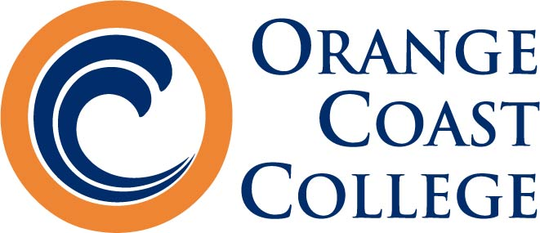
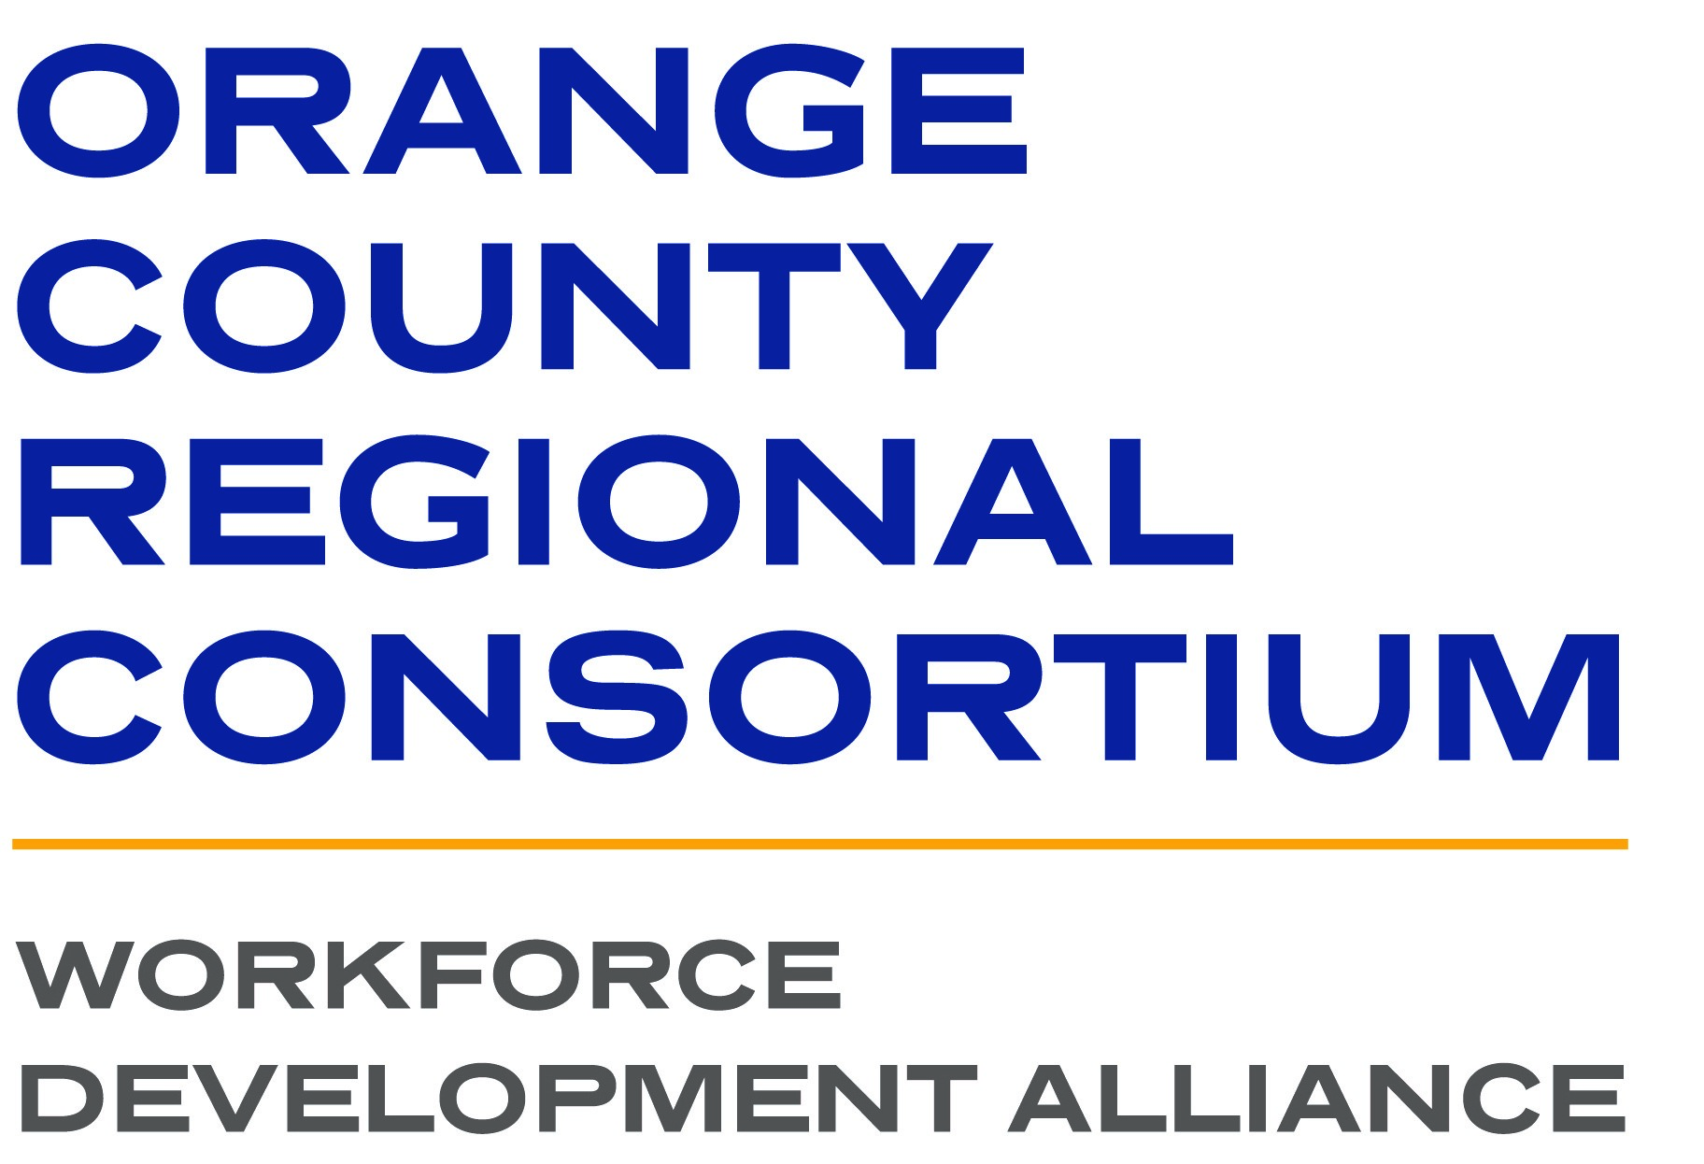

CTE REGIONAL COLLABORATIONS

Orange Coast College - Planetarium

2701 Fairview Road • Costa Mesa • CA • 92626

Thursday • September 21, 2023

10:00am-3:00pm

AGENDA

- Welcome and Introductions
- Working with your Regional Consortium
- ASCCC, Local Senates and CTE Faculty Engagement
  - CTE Liaisons
  - 10+ 1
  - CTE Liaisons
  - Resources and Services
- What is new in your Region
  - Curriculum Opportunities
  - Employer Collaborations
  - Funding Structures
  - College Updates
  - Baccalaureate Programs
- CTE Related Updates/Emerging Issues
  - AB 928 and General Education impacts on CTE
  - CCCCO Vision 2030
  - CCCCO California State Plan for Career Technical Education (CTE): A Vision for Equity and Excellence in CTE
  - Chat GPT/AI

LUNCH

- Minimum Qualifications
- Competency-Based Education/Credit for Prior Learning
- New Title 5 Regulations- Work Experience
- Early College/Dual Enrollment
- Wrap Up

