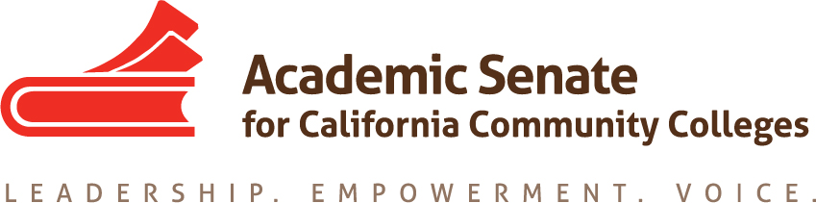

Career Technical Education Leadership Committee (CTELC)

CTE Liaisons March 2021 Memo
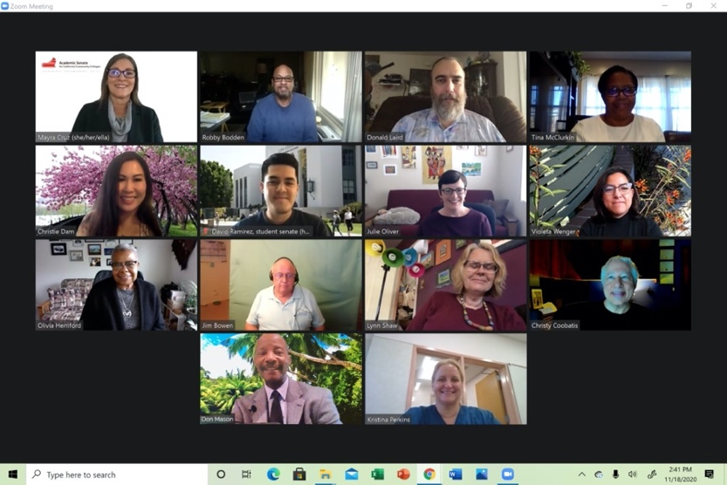
Dear CTE Liaisons,
Equity is defined by our system as the condition under which individuals are provided the resources they need to have access to the same opportunities, as the general population. Equity accounts for systemic inequalities, meaning the distribution of resources provides more for those who need it most. Conversely, equality indicates uniformity where everything is evenly distributed among people. Credit for Prior Learning is an opportunity within the system’s equity movement. This memo intends to provide various resources to advance CPL at your college/district. -Mayra
2020-2021 CTE Leadership Committee
Mayra E. Cruz, CTE Leadership Committee Chair, Julie Oliver, 2nd Chair
Emilda Baghdaserians, Robert Bodden, Jr., Jimmie Bowen, Angelica Campos, Christy Coobatis, Christie Dam, Olivia S. Herriford, Donald Laird, Don Mason, Tina McClurkin, Kristina Perkins, Lynn Shaw, Violeta Wenger

Credit For Prior Learning

What is credit for prior learning? “Credit for prior learning (CPL) is credit awarded for validated college-level skills and knowledge gained outside of a college classroom—it’s a strategy to grant students credit for what they already know and can do. On September 16, 2019, the Board of Governors of the California Community Colleges approved a revision to Title 5, Section 55050 that redesigns how students at California Community Colleges receive credit for prior learning. The new regulation aims to make the process more consistent and equitable for students who come to community colleges with college-level skills and knowledge acquired in a variety of non-classroom settings. Research suggests that CPL benefits students and colleges by increasing completion and closing achievement (equity) gaps.” (Credit for Prior Learning Policy Implementation Toolkit, p. 1) CPL is an important tool for Career Technical Education students, who often have experience in their chosen field when they arrive at the doors of a community college.

Resources

Credit for Prior Learning Initiative: Findings and Recommendations to Expand Credit for Prior Learning as a Vision for Success Strategy

California Community Colleges. CPL Policy Implementation Toolkit.

Cruz, M. Guiney, C., Lewis, J, & Martin, J. (November 2020) CPL as an Equity Lever

CO/ASCCC CPL Lunch and Learn series – zoom recordings & slides

CCCCO Policy Resources
- ESS Guidance Memo: CPL Implementation Guidance and System-wide Policy Advisory for the Approved California Code of Regulations, title 5 section 55050, Credit for Prior Learning (CPL), Effective March 20, 2020
- CCR title 5, § 55050. Credit for Prior Learning
- Edu Code CPL Statutes
  - § 66025.7 (all students)
  - § 66025.71 (military/veteran students)
- CCC Vision Resource Center (VRC) CPL Community Forum
  - CPL Policy Guidance Memorandums
  - CPL Implementation Toolkit
  - CPL Community Forum (connect with practitioners!)
  - PD events
  - Articles and research

Upcoming Events

2021 Career Noncredit Education Institute - Virtual Event
April 30-May 1, 2021

CTE Liaison Coffee Hour - Coffee, Tea, and GP: Sustaining Our Work and Ourselves
April 7, 2021
11:00 AM-12:00 PM

To request support or information email
info@asccc.org

