Budget and Finance Operational Committee

Tuesday, May 10, 2022

10:00 a.m.— 11:30 a.m.

Location: Zoom

Join from PC, Mac, Linux, iOS or Android: https://cccconfer.zoom.us/j/95295596568

Or Telephone Dial: +1 669 900 6833 (US Toll)

Meeting ID: 952 9559 6568
The Budget and Finance Committee is responsible for ensuring financial transparency, making recommendations to the Executive Committee for the annual budget for each subsequent year, and making recommendations on fiscal policies and procedures. This committee is also responsible for the review of budget performance and revision of the budget, if necessary. The Treasurer shall report on a periodic basis to the Executive Committee. (updated October 6, 2021)

Agenda

Attendance: Michelle Bean (chair), Dolores Davison, Krystinne Mica, Ginni May, Cheryl Aschenbach, Alice Hammar (advisory)

- Call to Order and Welcome
WHAT WAS THE FIRST THING YOU REMEMBER BUYING WITH YOUR OWN MONEY FOR A MOM FIGURE IN YOUR LIFE?

- Adoption of Agenda and Approval of February Minutes—attachment in calendar request
- ASCCC Investment Policy Draft Review—attachment in calendar request

- Office Space Lease Pre-pay Update—Given at April Exec Meeting

- Local Senate Travel Survey Review
  - Emerging themes—ED shared and recommended discussing and carrying over to next year. (incomplete)
  - Addressing which events to focus on for hybrid (four main—plenaries and two institutes)-Discussed at April 21 Officers Meeting

- Budget Categories Discussion and Possible Visual/Graphic
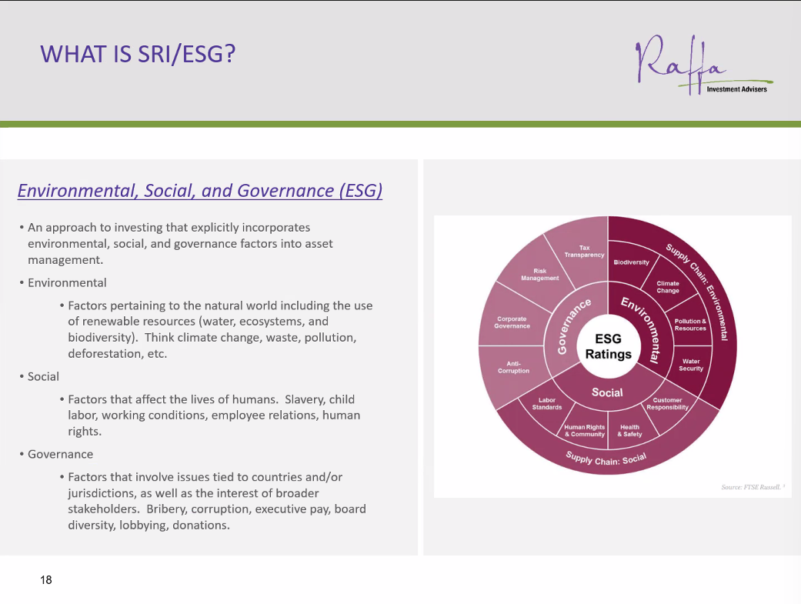

- 2021-2022 Goals for Budget Committee and End of Year Review
- Accessibility of financial documents—audit on website more visibly on its own page; breakdown of event costs on marketing and front facing documents; agendas/minutes posted on BC webpage.
- Recommendation for an email to body regarding evaluating budget impacts and AV costs (from ED, president, and treasurer and/or officers).
- Investment policy draft written and recommendation for investment firm RFP.
- Budget Categories—initial discussion of values-based budgeting but still incomplete

- Adjournment at 11:41 a.m.

