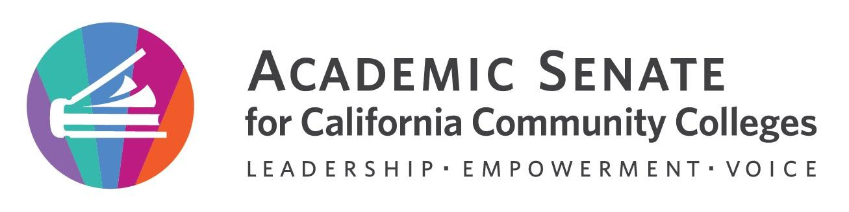
;;

Education Policies Committee Meeting

Wednesday, September 21st, 2022

12:00 p.m. – 1:00 p.m.
The Educational Policies Committee studies educational issues of concern to the Academic Senate and is the standing committee that recommends educational policies to the Executive Committee. The Committee provides a forum for high-level discussion and development of Academic Senate Policy, including its effect on faculty and students. The discussions include the viewpoint of students, CIOs and union representatives. The Educational Policies Committee researches issues as required, and writes background and/or position papers where appropriate. The Committee may pass general recommendations to other Senate committees, or work with them on more detailed implementation or technical issues. New or revised educational policies of the Academic Senate pass through the Educational Policies Committee. These may include policies to be implemented either locally or at the state level, suggested positions on proposed policies or changes in existing policies, and responses to assignments given by the President or Executive Committee.

MINUTES

- Call to Order and Roll Call:
The meeting was called to order at 12:05pm and attendance was taken.
Juan Arzola – 1st Chair | Stephanie Curry – 2nd | Maria Figueroa
Julie Clark | Lorraine Slattery | Christie Dam
Carlos Guerrero | Chantal Lamourelle | Matais Pouncil, CIO
Student Leader TBD

- Land Acknowledgement –
Chair Juan Arzola read the land acknowledgement and asked for input on the statement

We acknowledge that our campuses are located on unceded territories of Yokuts, Miwuk, Gabrielino, Tongva, Serrano, Cahuilla, and Luiseno peoples, who have continuously lived upon this land since time immemorial. We recognize the historic discrimination and violence inflicted upon Indigenous peoples in California and the Americas, including their forced removal from ancestral lands, and the deliberate and systematic destruction of their communities and culture. We have a responsibility to oppose all forms of individual and institutionalized racism toward all people but especially toward Indigenous peoples in which discrimination has occurred through the omission and silencing of Indigenous voices. We embrace our position as educators to collectively learn how to actively address settler colonial legacies. We honor Indigenous peoples—past, present, and future—here and around the world.

- Adoption of agenda, volunteer minutes taker, and Google Shared Folder 2022 – 2023.
The agenda and minutes were approved by consensus. Stephanie will take minutes.

- Meeting norms and social agreements
The committee norms were reviewed. The norms were created at the previous meeting

• Share information and workload
• Follow through with actions
• Facilitate the committee work
• Ask for help
• Be open-minded
• Be accountable

- 2022 – 2023 Educational Policies Committee Goals and Priorities.
2009 Enrollment management update
The committee discussed the intent and goals for the updated enrollment management paper. The committee reviewed the outline from last years committee and discussed any needed changes. The Committee review the current drafts from last year. This work can be used as a foundation for the work of this years committee. Committee member volunteered to start working on sections

Part I- Juan, Carlos
Part II- Stephanie, Julie, Carlos, Maria, Christie
Part III- Juan, Maria, Chantel
Part IV- Stephanie, Julie
Part V- Chantel, Christie
Part VI- Matias, Juan

The committee has a goal of a first draft for Exec in January 2023. Groups agreed to meet to do this work between meetings

Timeline for completion 2022-2023
- October- research and outlining
- November- drafty draft
- December- review draft
- January- first draft for Exec Committee
- February-make any recommended changes from Exec Committee
- March- final version ready for Spring 2023 Plenary

Recommend check in times at meetings in Oct, Nov and Dec for section writers. Perhaps a 15-minute breakout for groups

Committee may have an in-person meeting to work on paper in Fall 2022

  - Rostrum articles
The previous years committee recommended a rostrum article last year on Student Academic Dishonesty. This committee may continue work on this article
The committee also had an opportunity to suggest ideas for future Rostrum Articles
    - Ideas for this year
      - Academic freedom, equity, and antiracism?
      - Others?

- Announcements
Juan shared announcements about upcoming ASCCC events.
  - Fall 2022 Plenary
    - November 3 – 5 Sacramento
    - Theme: Centering Authentic Voices and Lived Experiences in 10+1 (To be finalized at Sept. 30th ASCCC Executive Board meeting)
    - Presenters and session descriptions due October 1
  - Check for upcoming events at here

- Adjournment
The meeting adjourned at 1:05pm

In Progress
- Enrollment management paper rewrite
- Student Academic Dishonesty rostrum paper

Completed Tasks:
- Established meeting norms and social agreements

